Ching Hey Lau

Chinghey.lau@newhallstudent.co.uk

Investigating project

Computer science NEA 2022-2023

Unity 3D game making

Content Page

1. Analysis 3

1.1 Introduction 3

1.1.1 Background 3

1.1.2 Project Scope 3

1.1.4 Target audience 4

1.2.1 Investigating Project 4

1.2.1.2 Questionnaire and Statistics 4

//ask perspective user 4

//purpose of question //result, graph and chart 4

1.2.1.4 Existing Software - related to my project (investigating) 10

1.2.1.5 Prototyping 17

1.2.10 Analysis Data Dictionary/ Possible Variable & Methods 18

1.2.11 Data File Size /Volume 18

1.3 Specific Objective //measurable //achievable //validation – should need 18

1.3.1 Splash Screen 18

1.4 Proposed solution 20

2. Design 21

2.1 High-level overview 21

2.1a System flowchart (Data flow diagram) // Articulate design, (load save) smartdraw, draw.io 21

2.1b Class diagram (abstract classes and interfaces) 22

2.1d Variable declaration of Main Algorithm 35

2.2 Modular in structure of system 35

2.2a Structure chart /Site map 35

2.2b IPSO 36

2.3 Data Items & structures //Dynamic or fixed? How will it use heap? 36

2.4 Database design (Normalised ER diagram 36

2.5 File Structure and Organisation 37

2.6 Identification of main algorithms //Use Structured English OR Pseudocode 37

2.6a A* 37

2.6b Maze Creation 37

2.6c Linked List 37

2.6d Merge Sort 37

2.6e Binary Search 37

2.6f Daylight System 37

2.6g Inventory 37

2.6h Menu/ UI manager 37

2.6g Singleton (Audio) 37

2.7a Online Query 37

2.7b local SQLite Query in Save0/1/2.sqlite3 37

2.8 Identification of Storage Media 41

2.9 HCI Rationale rationale for choosing this 41

2.10 HCI Sample of Planned Input Design //storyboard //drawing of the sample game scene 41

2.11 HCI planed output design 43

2.12 Hardware and Software requirement 44

2.13 Description of measures planned for security and integrity of data 44

2.13a Security of the data 44

2.13b Integrity of the data 44

2.13c Access Control 44

2.14 System security //physical attack 44

SQL injection using paramieterised SQL Query to prevent the 44

2.15 Overall Test Strategy //how you conduct a test + user acceptance 44

3.0 Technical Solution 44

4. Testing – Testing is completed or not 45

5. Feedback and Evaluation 46

# 1. Analysis

## 1.1 Introduction

### 1.1.1 Background

Maze Runner has been a best-selling thriller movie since its release in 2014 and is based on the novel by (name). In the story, a group of boys who are immune to a zombie virus are trapped inside a mysterious maze for scientific investigation. Scientists have found that higher brain activity creates more immune substances, so they put in a giant and poisonous monster called Griever. They are trapped inside a moving maze with a different opening sequence every day. The story is about the main character, Thomas, who has been trying to uncover the secret of the maze and leading a team to get out of the maze.

This film is one of my favourite movies as the audience gets immersive as Thomas, through him, we understand how the maze works and the relationship and mentality of the aborigines. The scene of Thomas bravely exploring and surviving inside the maze successfully made the audience feel intensely worried about him. After the movie, I had been dreaming of myself as Thomas, dealing with the "horrible monster" and exploring and escaping the maze. Also, as a survival movie, humanity, betrayal, and trustworthiness have been emphasized, which has lightened our lives' principles.

There are lots of maze-solving games, but only a few of them are similar to the movie. I would like to make a game on top of the original storyline that would simulate Thomas, the main character, contributing to the village and communicating with and building relationships with NPCs. And once Thomas has gained enough resources, he can solve the maze, escape, and handle the zombie outside of the maze. Also, I would like to make this game as realistic as possible, as the settings and story of the game could happen, and the player needs to immerse himself in the world of The Maze Runner.

### 1.1.2 Project Scope

The genre of my game will be Role Play Game and maze solving game. As an RPG game, the player will substitute into the main character to grow and explore the maze and villages. The resource will be randomly generated in the zone like woods in the forest zone. Food can be found in the farming zone which randomly generated every 2 days. Houses with a craft table which used for building tools and trap will be in the village zone.

There is similar type of maze game called labyrinth game. However, labyrinth game doesn’t aim to be explore or solve. It provides a fixed path without a dead-end. In compare to maze-game which is opposite to labyrinth leads to higher difficulties. To make the game fun to play, the maze is randomly generated in every new game so the player wont get bored or reciting the maze pattern and gate opening sequence.

The maze will be generated with an algorithm to create a floor cell and patterns of vertical and horizontal wall. It will be

The game should be intense to play so the attack of monster and player could be more creative and painful including using trap that slow down of the monster speed/ damage and some make the player poisoned. The difficulty of confronting the Griever will gain reward to player either it is a key of opening the maze or a rare item which can be weaponise.

Player has to find out the opening sequence as password and monster key frop

Careful to the health bar

To match the setting of the movie, player is transported through a lift to the maze which

. Then player needed to understand the storyline and introduction through the dialog with different NPCs. After the player has collected wood and leather, the player should be able to create and equip some tools made by the resources player has collected to enhance himself for fighting and defence. He will permit to enter the maze and receive a basic kit as the runner(explorer) of the maze.

As the movie “Maze Runner” only showed 1 type of the maze, the maze texture could have more variant such as Japanese traditional temple maze and palace in Beijing as background. The UI could also design as command line like because the whole maze is generate by super-computer and the setting is future based.

I would build this game on mobile platform so the button needs to be touch friendly. Some of the character will based on the movie and it is provided with different speed and damage­­­­

### 1.1.4 Target audience

Based on the result collected from the Questionnaire in 1.2.1.2, the game will target into male gamer around 15 to 25 which most of them is student. Most of the respondents do play game however the time is quite short and mainly plays at weekend or 1-2 days per week. Also, mobile platform and Nintendo switch are popular platform teenages played on and also because of the easy to access in terms of hardware and time. Most of the teenages now owned a mobile phone, low cost than a pc and time available has convinced to build the game on mobile platforms. As this game are aimed at realistic, blood effect and challenging maze will be included so this game wont be available for children

## 1.2.1 Investigating Project

### 1.2.1.2 Questionnaire and Statistics

===================Personal Detail/ client ======================

1. Gender

Male ----(5 votes) (71.43%)

Female----(2 votes) (28.57%)

1. Age Range

Under 12 ----(0 votes)

12-15 ----(0 votes)

15-17----(2 votes) (28.57%)

18-25 ----(5 votes) (71.43%)

26-35----(0 votes)

Over 35----(0 votes)

1. What is your job currently

Part-time job ----(1 votes)

Student ----(6 votes)

1. How often do you game?

I don’t play game ----(0 votes)

Weekend ----(5 votes) (71.43%)

3-5 days per week ----(0 votes)

Every day ----(2 votes) (28.57%)

Most of the respondents play on weekend. This game should not forced player to login everyday to gain special items

1. How long do you game?

0-1 hr/day ----(4 votes) (57.1%)

1-2hrs/day ----(1 votes) (14.3%)

2-3hrs/day----(2 votes) (28.57%)

more than 3 hours /day ----(0 vote)

Most of the respondents play less than 1 hour, adjusting the game to be fun and intense as well as using less time to complete.

1. How often do you open a game more than once in a day

Always ----(4 votes) (57.1%)

Seldom ----(3 votes) (42.9%)

Never ----(0 votes)

the game should consider having a pause and continue function as the player so the player can continue the session that have been left before.

1. What game platform do you prefer

Mobile ----(3 votes) (42.9%)

PC ----(5 votes) (71.4%)

XBOX or PS4 ----(2 votes) (28.6%)

Nintendo switch ----(3 votes) (42.9%)

Although PC has the most vote, mobile platform including mobile and Nintendo switch combined has gained larger portion than PC player

1. What kind of game do you prefer

Role-playing Game ----(4 votes) (57.1%)

First Person Shooter ----(5 votes) (71.43%)

Third Person Shooter ----(1 votes) (14.3%)

Battle Royale ----(2 votes) (28.6%)

Arcade game ----(2 votes) (28.6%)

Sandbox (Minecraft/ Terraria) ----(5 votes) (71.43%)

Puzzle / Problem solving game----(3 votes) (42.9%)

Action-Adventure game ----(4 votes) (57.1%)

Most People like sandbox, First Person Shooter. These prove most respondents familiar with playing 3D game and know most of the 3D game mechanics. Role-playing game and action adventure game come as second which shows the rewards and game experience is important to the player.

=========================Gameplay ========================

1. how long should one game session last?

5 -10 mins ----(1 votes) (14.3%)

10-15 mins ----(4 votes) (57.1%)

15--20 mins ----(2 votes) (28.57%)

most of the people don’t want a game last too short or too long. 10 -15minutes the best time range for most of the respondents

1. In a game fighting with AI monster, what weapon would you prefer?

melee ----(1 votes) (14.3%)

Explosive----(2 votes) (28.57%)

knife ----(1 votes) (14.3%)

punch ----(0 votes)

arrow or throwable weapon-----(5 votes)(71.4%)

most of the player would like to deal some damage to the monster without getting too close to the monster. Throwable weapon will be added as a weapon option

1. What fight mode do you prefer?

defensive(trap) ----(1 votes) (14.3%)

attacking (arrow, stone, sword and maybe gun) ----(6votes) (85.7%)

most of the player would like to active attack the monster instead of defensive playing. It is because defensive is more unpredictable compare to attacking. And rewards from killing monster by player himself.

1. Which one do you prefer the frequency of monster appearing?

Weak but abundant ----(1 votes) (14.3%)

Strong but few ----(6 votes) (85.7%)

Most of the respondents prefer few monster but will high damage or enhanced health.

1. In a game, which mode do you prefer

Endless mode ----(0 votes)

With an ending (then restart) ----(7 votes) (100%)

Most of the player want to have a game with an ending. An ending could be a emblem of player beating the game

1. After the game end, how should the game behave?

go to next level ----(5 votes) (71.4%)

stay at current game session----(2 votes) (28.57%)

Most player wants to challenge for a harder level instead of improving the current score and level before move on. The player may have limited time so next level will automatically loaded after the player beat the game.

1. Which attack mode do you prefer

Aim to attack ----(5 votes) (71.43%)

Distance to attack ----(2 votes) (28.57%)

most of the respondents would like to attack the monster precisely by aiming with crosshair and make the game more realistic.

1. Should NPC (AI) affect the overall gameplay? Different objective

Yes ----(6votes) (85.7%)

No ----(1 votes) (14.3%)

The NPC could prove different objective and reward after objective have met. Also, the key of opening the gate could also be gained by killing the monster.

1. should game add a loot box(chest) or bonus box

Yes----(7votes) (100%)

No ----(0 votes)

A loot box should be automatically spawn at the start of the game and loot box will spawn inside the safe zone

1. Which one do you prefer

Time limited ----(2 votes) (28.57%)

No time limit ----(5 votes) (71.43%)

Most of the respondents don’t want to have a limit on time. It may because it is have too much pressure on playing a game.

1. Which way is the best way for a player to gain money

collect resource gems ----(0 votes)

loot from the monster ----(1 votes) (14.3%)

complete the quest ----(5 votes) (71.43%)

Selling stuff and earn token----(0 votes)

By working, wood-cutting, farming ----(1 votes) (14.3%)

Most respondents has chosen completing the quest to gain money. It could combine with the objective provided by the NPC.

1. Should level system link to difficulty

Yes----(6votes) (85.7%)

No ----(1 votes) (14.3%)

most of the respondents would like to merge difficulty with level which means higher level will be more difficult.

1. should the game include weekly login/daily login bonus?

Yes ----(4 votes) (57.1%)

No ----(3 votes) (42.9%)

The game should award player who play this game every period of time by giveaway rare weapon and coins

1. Do fast travel/ player teleport affect game balance

Yes ----(5 votes) (71.43%)

No ----(2 votes) (28.57%)

Fast travel will affect the game balance according to most of the respondence so this feature will not be add into the game. Reason may be unfair to the time used to other player.

1. when the final boss killed, should side/minor monster be

Stay in the game for player to kill ----(3 votes) (42.9%)

Die with the boss ----(4 votes) (57.1%)

Tame-able/loyal to player ----(0 votes)

All monster should be dead when the boss (main monster) is dead.

1. When should the monster awake and chase the player?

Only daytime ----(0 vote)

Only night-time ----(2 votes) (28.57%)

Both----(5 votes) (71.43%)

s the monster can trigger loot and reward, most of the respondence are willing to fight with the monster no matter when the time of the day is.

1. Should day and night last

fast ----(4 votes) (57.1%)

slow ----(3 votes) (42.9%)

most of the respondents prefer faster paced game and it could save the time and make the game become more intense.

1. What player should award by finish objective

Token/ coin ----(1 votes) (14.3%)

Level up ----(1 votes) (14.3%)

Rare weapon ----(4 votes) (57.1%)

Power and effect (strength and invisible) ----(1 votes) (14.3%)

Most respondents chose rare weapon as an reward after finishing the objective of the game.

1. What powerup do you like to appear most oftenly

Strength -more attack ----(4 votes) (57.1%)

stealth, invisible----(4 votes) (57.1%)

Run 1.2x faster ----(4 votes) (57.1%)

Get the path of the maze ----(1 votes) (14.3%)

There is a tie with strength, stealth and speed boost power-up. Those 3 of the powerup would be randomly chosen by the system

1. For easy level

decrease monster hp (health) ----(5 votes) (71.43%)

increase damage of weapon ----(1 votes) (14.3%)

higher chance to get expensive item ----(2 votes) (28.57%)

The monster health should be decrease to match the difficulty of easy level.

1. How should level be measured

By monster kill count ----(1 votes) (14.3%)

By money earned ----(1 votes) (14.3%)

By number of objectives finished ----(3 votes) (42.9%)

by timer ----(2 votes) (28.57%)

Most respondents agree to have the more objective finished, the higher level you could earned.

1. Earn money by

timer ----(0 votes)

killing count ----(7votes) (100%)

Most respondents would like to gain money by player killing monster.

1. which one do you prefer

multi tab setting menu----(5 votes) (71.43%)

scrollable setting menu ----(2 votes) (28.57%)

Multi-tab setting menu would be used in the setting menu of my game

1. should monster start attack you in sight

Yes ----(6votes) (85.7%)

No ----(1 votes) (14.3%)

The monster will attack player only when monster have seen player

1. would you rather have a default weapon or random weapon provided?

Default weapon (strong) ----(3 votes) (42.9%)

random weapon (sniper, shotgun, AK 47) ----(4 votes) (57.1%)

Most respondents would like to have different choice and properties of weapon

1. In the game, which chasing method of monster you prefer?

moving to you slowly constantly ----(5 votes) (71.43%)

moving fast but stop in a while ----(2 votes) (28.57%)

The speed of the monster should be slower than the walking speed of the player to give enough space for player to attack and escape

1. Which kind of currency do you prefer

counting in dollars ----(6votes) (85.7%)

counting in 100 ----(1 votes) (14.3%)

Most respondents prefer a actual amount of imaginary large number of money in game

1. where do you want to path appear?

On the mini-map ----(6votes) (85.7%)

visible on the floor ----(1 votes) (14.3%)

There should be a path visible in the mini-map inside the game

1. Should weather affect the movement?

(Rainy day walk slow, sunny day speed boost)

Yes----(4 votes) (57.1%)

No ----(3 votes) (42.9%)

The weather system should be added into the game which special effect due to the weather

1. If player die, should the player

Be punish in some way (health bar decrease or some coin lost) ----(4 votes) (57.1%)

act like nothing but death count + 1 ----(3 votes) (42.9%)

Over half of the respondents would like to have a punishment when the player is dead

1. If the player respawn, should player spawn in

the safe zone (far from exit) ----(7 votes) (100%)

where player dead (maybe unsafe or near to another trap) ----(0 vote)

Most respondents would like to respawn into the safe zone no matter they have to reexplore the map again

1. Which aim do you prefer?

Kill 20 monster ----(4 votes) (57.1%)

Explore 3 zone ----(4 votes) (57.1%)

Survive a cruse night attack ----(4 votes) (57.1%)

collect 30 coins ----(1 votes) (14.3%)

Find a secret tunnel ----(4 votes) (57.1%)

Objective that respondents would like to have is killing certain amount of monster or a wave of monster, exploring the map and the secret tunnel.

1. Which perspective you would like a 3D Maze Runner to be?

First Person ----(1 votes) (14.3%)

Third Person ----(1 votes) (14.3%)

Both (switchable) ----(5 votes) (71.43%)

Most respondents would like to have a choice changing between first and 3rd person perspectives

1. Do you like lobby music (background music)

Yes ----(5 votes) (71.43%)

No----(1 votes) (14.3%)

Sometimes ----(1 votes) (14.3%)

Most of the respondents would like to have music playing in the background while in main menu and game lobby

1. Should the speed/ strength of different character be different?

Should be different ----(6 votes) (85.7%)

Should be the same ----(1 votes) (14.3%)

Most respondents would like to see more variant available in the game including characters and their own different abilities

1. What is the best way to heal/ recover health?

Buy food from the shop (spend money) ----(6 votes) (38%)

Free limited supply of medicine each round----(4 votes) (24%)

Collect heart from the ground----(2 votes) (13%)

Kill monster and have a chance to heal----(4 votes) (24%)

Most respondents prefer spending money to buy medicine to recover the health.

1. Which power-up would you prefer

speed increase ----(5 votes) (71.43%)

destroy monster near player (in range) ----(2 votes) (28.6%)

Slowness ----(1 votes) (14.3%)

Strength ----(6votes) (85.7%)

Instant health increase ----(5 votes) (71.43%)

Resistance to attack ----(4 votes) (57.1%)

Invisible/ Invincible to monster ----(4 votes) (57.1%)

Most of the respondents prefer having strength power-up which deals more damage to the monster.

=================Comment on my game ============================

1. Have your ever watch maze runner （移動迷宮）？

Yes ----(4 votes) (57.1%)

No ----(3 votes) (42.9%)

the next 2 question will be based on the answer from question 46

Most of the respondents have watched maze runner.

1. Do you like that film?

Yes ----(4 votes) (57.1%)

No ----(3 votes) (42.9%)

All of the 4 respondents who watched the movie like the film. This proves the high selling box office of the maze runner has gained exposure and reputation could made this game become popular and easy understand plot.

1. What feature of the movie would you prefer to add into the game?

(The monster? the WCKD laboratory? the farming in safe zone?)

-WCKD laboratory

-The farming area in safe zone

-Storyline from the movie

The zone could contain farming section. WCKD laboratory and the storyline from the movie could be added and adjusted to make the game similar to the movie

========================Feature ==============================

1. what additional feature I didn't mention above is suitable for maze game?

(This would help a lot and better to my game)

-resistance to monster attack

-a rare chance for player to fly on the sky for few second so that the player can know the maze structure a bit

-earn new characters

-rare item loot chest in secret tunnel

The character could be bond with the award system. Power-up like invincible and maze reveal can be added to the game. Rare item can be placed in secret tunnel to award player

1. Why do you play game? What aspect of game you enjoy the most?

-Kill

-relax (2 votes)

-Getting progress e.g., level up, being stronger

enjoy teamwork or play alone

-Maze is fun

-Happiness of passing a level

Main Conclusion:

### 1.2.1.4 Existing Software - related to my project (investigating)

Game 1: Escape the glade

This game is describe as inspired by movie “maze runner”. The texture is similar to the movie and storyline is pretty much the same

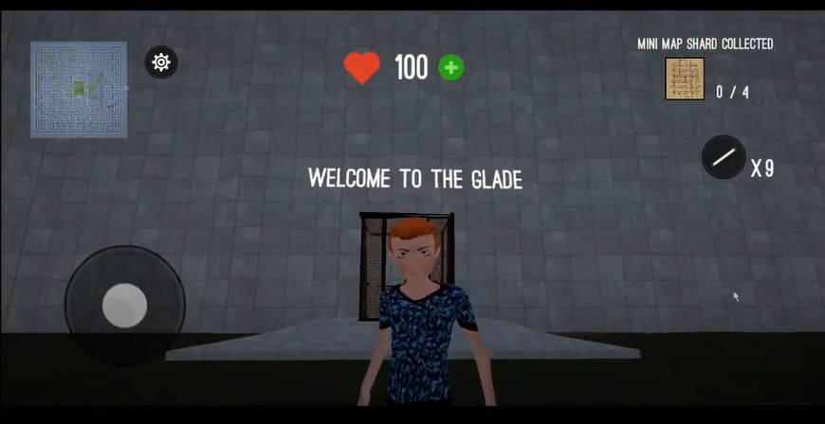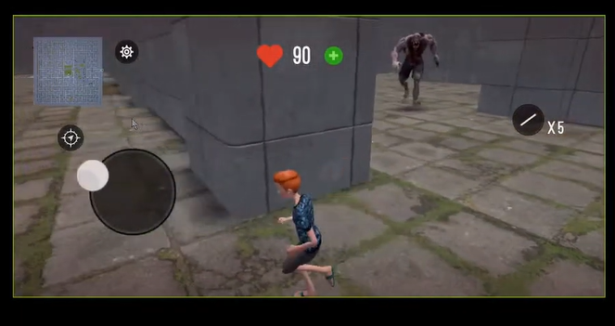

Pros:

* The sky and the wall texture are good and clear to see and identify
* There is different texture between grass and wall and similar to the movie maze runner
* It has a simplified mini-map and real time locate player location
* A lift is transported at start and the end of the game which pay tribute to the movie
* A light bar that allows you drop on floor for bookmarking the direction of player
* Graphics setting is included to make the game compatible with less powerful phone
* The lobby music is energetic to player
* Power-up and health boost available by watching ads
* The player and monster animation is fully animate and runs smoothly

Cons:

* There is no way to take the monster down (no trap and attack method)
* The map is too complex, can’t win this game without screenshot the map and planned beforehand
* This game is easy to get lost but the monster keep chasing you
* No achievement after you successfully escape
* The lobby music is repeat and become annoying at a few time.
* You can go back to the laboratory as the lift doesn’t disappear after start
* The blood effect affects the camera vision and it never disappear
* Mini map should update even though it is closed
* The monster keeps following the player wherever player is (even though player is not in sight of the monster)
* There is no safe place or cooling down for monster chasing
* The map is not randomly generated (same map everytime)

Conclusion: Unlike the movie, the maze is fixed and only one objective. It is quite boring whilst the monster is too overpowered. This game uses unreal engine, this explain why the graphics and texture is rendered perfectly match. The map should be more straight-forward and without any external tools for player easier to solve. My suggestion is add a navigator and ability to draw and highlighted in the minimap. The monster chasing is very annoying as I cant pause and play the game relaxly. I would add a combat system to allow player to kill and defence from the monster. For example, powerful weapon and armour protection and able to setup some trap like a speaker making some noise to attract the monster and confuse them. The monster that killed by the player could drop some loot and clue. I would add some more NPC to assist the player and some more variant of monster. Furthermore, the ability to locate the monster in the minimap could help player to avoid them. The blood recovery system and navigation system are connected to ads however the ad service is not working which is disappointed as the blood can’t recover and it affect the gameplay. I would suggest having some ways to heal himself. Moreover, as the map pattern is fixed and complex to solve. Player needed to screenshot and plan the route before solving the maze. It is nearly impossible to solve it at one go or without planning. Blood effect should be minimal because it keeps showing on-screen affecting the whole gameplay.

Game 2: RPG-Maze

This game has a random map generator which is a bonus and delight me a lot. This game use stereogram texture. The camera is free to move too.

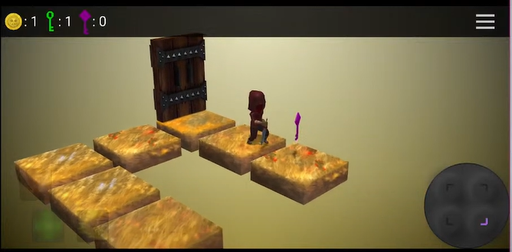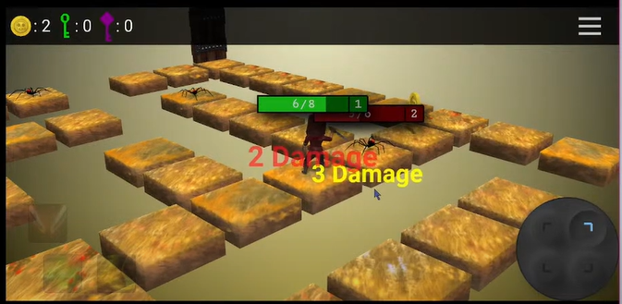

Cons:

* The input is hard to input and control as it is 4 spereate buttons and it is fixed at corner which hard to reach
* Walking speed/ animation is too slow (better if timescale could double or Fast-Forward
* This game has no jump option which wasted a lot of time going a sim
* The damage of fighting is too random and unpredictable
* The high pitch lobby music keeps looping makes me feel annoying

Pros:

* Good UI – including joystick, health bar and health change text
* Predictable monster movement
* Player can deal one more damage to the monster as the monster attack is delayed
* The loading screen is fancy and separate from the main game
* Achievement and reward after finishing the level
* The animation of the character walking is fully animated
* Background music is included in the game
* The setting have a option to turn off the music
* The map is randomly generated even though it is in the same level
* Token and Power-up system [fire/ sprint/ heal system]
* Level preview function (provide a detail of number of monster and keys)

Conclusion: The objective of this game is quite clear. They are all located at the top with an icon. Tutorial is clear for player and player could easily understand and follow. The collection of the key is also the main objective of my game as it is used for open the maze so I could use it as a reference. However, pattern of the key generation in this game are usually located at the furthest corner which player needs to takes a lot more time to finish a simple task. Also, the character moves quite slow, I would consider adding a speed up option for player. Although this game have a advantage on delayed monster attack, it also have a unfair combat system because the damage are unpredictable which is a risk to challenge monster in this game.

Game 3: Endless Maze Runner Survival 2

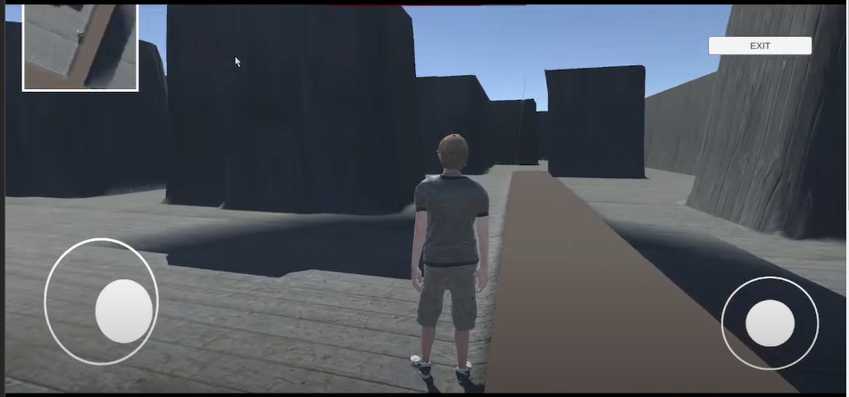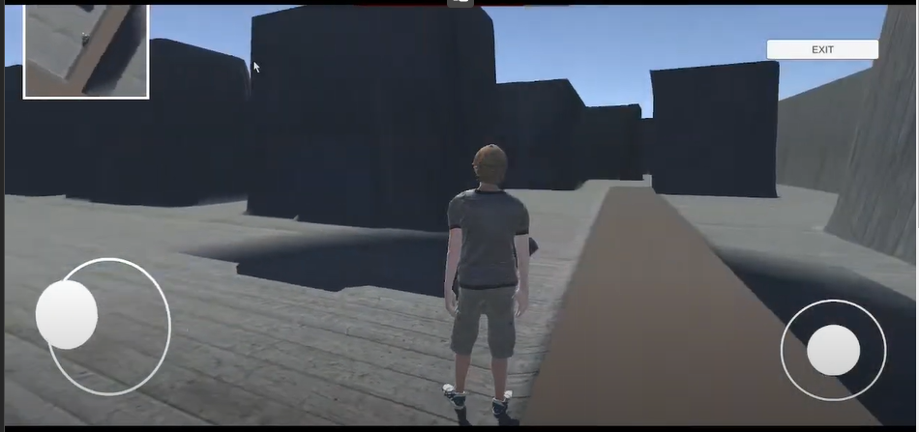

Pro:

* The game is playable and joystick control is quite good
* The movement and turning could be a reference to my game
* The minimap to show where the player is locate

Cons:

* The texture is too simple/ not attractive
* This game has no interactive element, NPC nor monster.
* There are only 1 level in the game.
* It is impossible to find the exit as there are no any hints on mini map or the game
* This game has no other objective and easy to get lost
* The camera can look through the wall in Third Person Perspective
* There are too many ads in the game. When ads appear at start and end of the game
* There is no day-night shift and the shadow of the wall is unrealistic as some of them are floating in the mid-air
* The position of joystick cannot be adjust which is not user-friendly
* The speed of the character is too slow. It takes more than 15 seconds to walk to the finish line in a short distance

Conclusion: The game engine, the setting and the map of this game is similar to my prototype. However, the outcome of this game is unplayable. The minimap in this game could be improve as it is completely useless to solve the maze. But this game has quite natural and responsive animation while the character is moving.

Game 4- Maze RPG Dungeon

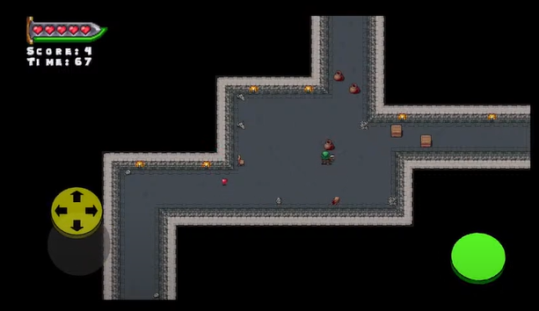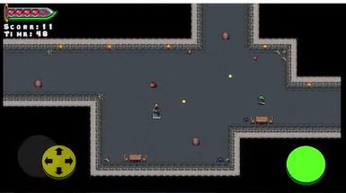

Pros:

* The text has cool effect and colour gradient
* The button is 3D design
* The wall and the floor are easily distinguished
* Lots of additional entity in the game
* Tutorial which easy understand how to game works
* Time limited game, must pass before time<0 and award of the remaining time
* Have different section of the maze zoom in. (wont too small, clear)
* Random loot from the box on the ground
* The monster shoot fireball which predictable and avoidable by the movement of the player
* The health item on the floor is available to pick up and recover the health
* Effect/ hint pop up, telling player what update (such as: health +2)

Cons:

* The joystick is not response instantly. It needs times to “accelerate” the player movement
* There are no any setting menu, login menu, save menu and pause menu
* If you switch out and back to the game, you have to restart your level because it forces quit and doesn’t save the progress in the background
* If you get hit, you can’t move. Not ideal when escaping from a monster
* No idea how the map work, no direction, no exit, no mini-map and how could you escape
* The distance of attack is unclear
* No way to counterattack of the fireball dispenser

Game 5- Maze Runner 2D

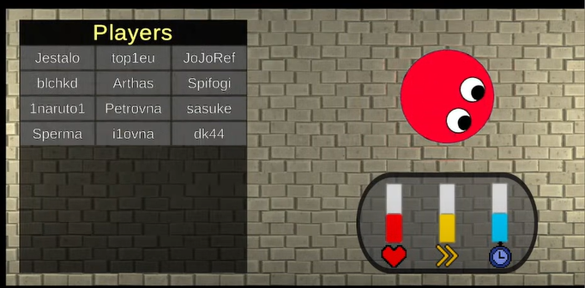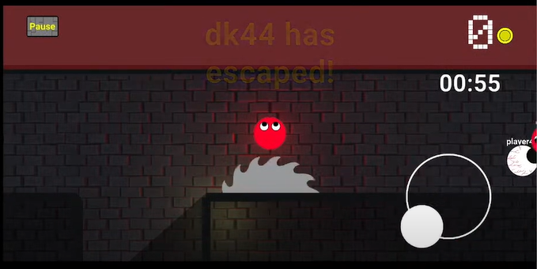

Pros:

* tutorial at the game start – (show dialog box and visible when introducing the UI)
* Use light to show where you are in sight and where you can’t see [dark]
* The lighting is varied in different area
* Use the “eye” to tell player ball going position
* Pressure plate as a trap [barely to see]
* Coins system
* One way only[like ice skating rink]
* The green part
* There is no pause menu during the game
* The joystick which controls player movement is located at right hand side.
* Shop system to spend your money wisely
* Different character has different ability (health level, speed and time level)
* Character preview on waiting screen
* System broadcast
* Some powerup to slow people down (use particle)
* Continue/respawn (by via watching ads)
* Use poison zone to limit the size of the map
* Trap inside the game (circular saw move around the map)

Cons:

* “multiplayer” game – random name generator
* Time limited – too fast
* The blade is too fast and large, hardly escape from it [should have more time for player to react to it
* No pause menu button

Conclusion: This game should have a pause button. It is paramount for people who spend their spare time to play unless it is online multiplayer game. However, the game is quite fully developed, and each opponent have AI script that looks real. Although it has tutorial at the beginning of the game, but the direction is unclear and unable to reach the finish line. Adding a mini-map could help the player to navigate a lot better

Game 6 – Labyrinth Legend

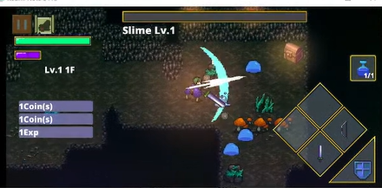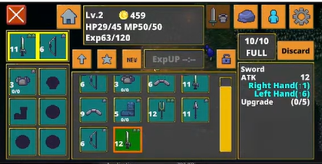

Pros:

* Language selection
* Google play integration
* Personalize by asking you to enter your name – double check
* Rich in setting – From graphic quality to music and visual setting
* Stat and achievement are in the setting menu
* Layout can set by user
* Allow session to restore (file saving) and cloud save
* Staff credit
* Story is told at the beginning of the game
* The control is responsible and interactive
* The character movement is fast and particle of walking on the ground
* Dynamic joystick
* Predictable and avoidable monster attack by using (!) to alert player
* The damage deal to the monster
* The attack range is insight with the animation
* Able to attack and defend from the monster
* There are shielded to block any damage from the monster
* Recover health /heal by drinking limited drug [ 1 per each round ]
* Could replace another weapon like bow in inventory menu
* Weak but abundant (easy to kill) (monster with loot drop including the key)
* Monster health bar is show as UI
* Monster awake system (if monster is not in sight of you, they won’t chase you)
* Monster attack will give you knockback(may move you)(reality)
* Broadcast with any new update on inventory or experience earned
* There is no cooldown of the weapon
* Use portal to teleport to the next level
* Random loot from the ground by clearing the grass
* Sorting function in the inventory
* A lot of NPC provide objective to player
* Comparison system of two weapon [damage? Speed?]
* The setting and inventory in pause menu are multi-tab
* The coins that monster drop will absorb by the player
* A lot of trigger dialog box on the map and with NPC -interactive

Cons:

* Setting is un-categorise
* The setting menu and inventory is combined with the pause menu
* No map to solve
* Each round is a new round (objective = kill monster only and get into portal)

Game 7 – Stumble guys

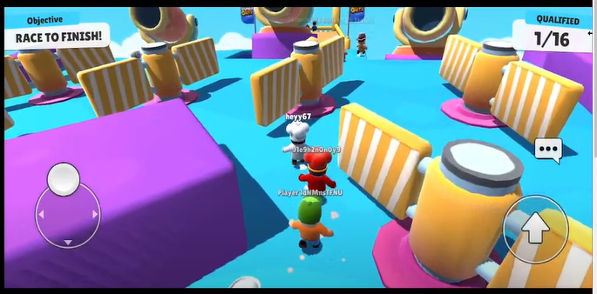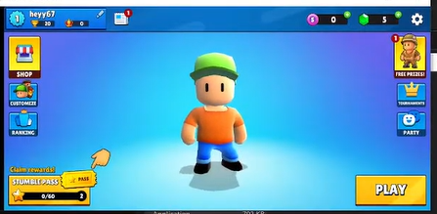

Pros:

* Multiplayer experience is prefect
* Allow player to create a server by hosting the room and invited others by invite code
* If the host leave, the owner of hosting transfer to one of the player
* Real time player movement
* Fully developed achievement system
* Personalise by changing the name and different clothes customization
* Shop system integrated with daily bonus – attack player to check in everyday
* Leader board system and can be sort by region
* Maps are randomly selected
* Good and realistic physic system and animation
* The UI is clear and children-attractive with friendly cartoon
* Traps are predictable by it look (bouncer, spring or cannon)
* The weather affects the gameplay (Icey will walk slippery)
* Game-over page but show your reward, conclusion (finished round 3), coin and exp
* One objective each round. Clear to understand

Cons:

* Stable network connection is basic requirement
* The trap is unpredictable

system of this game because it’s algorithm makes the game movement looks so real

### 1.2.1.5 Prototyping

1. Movement

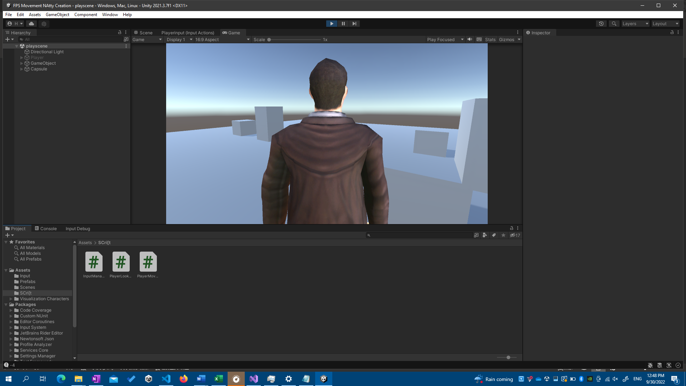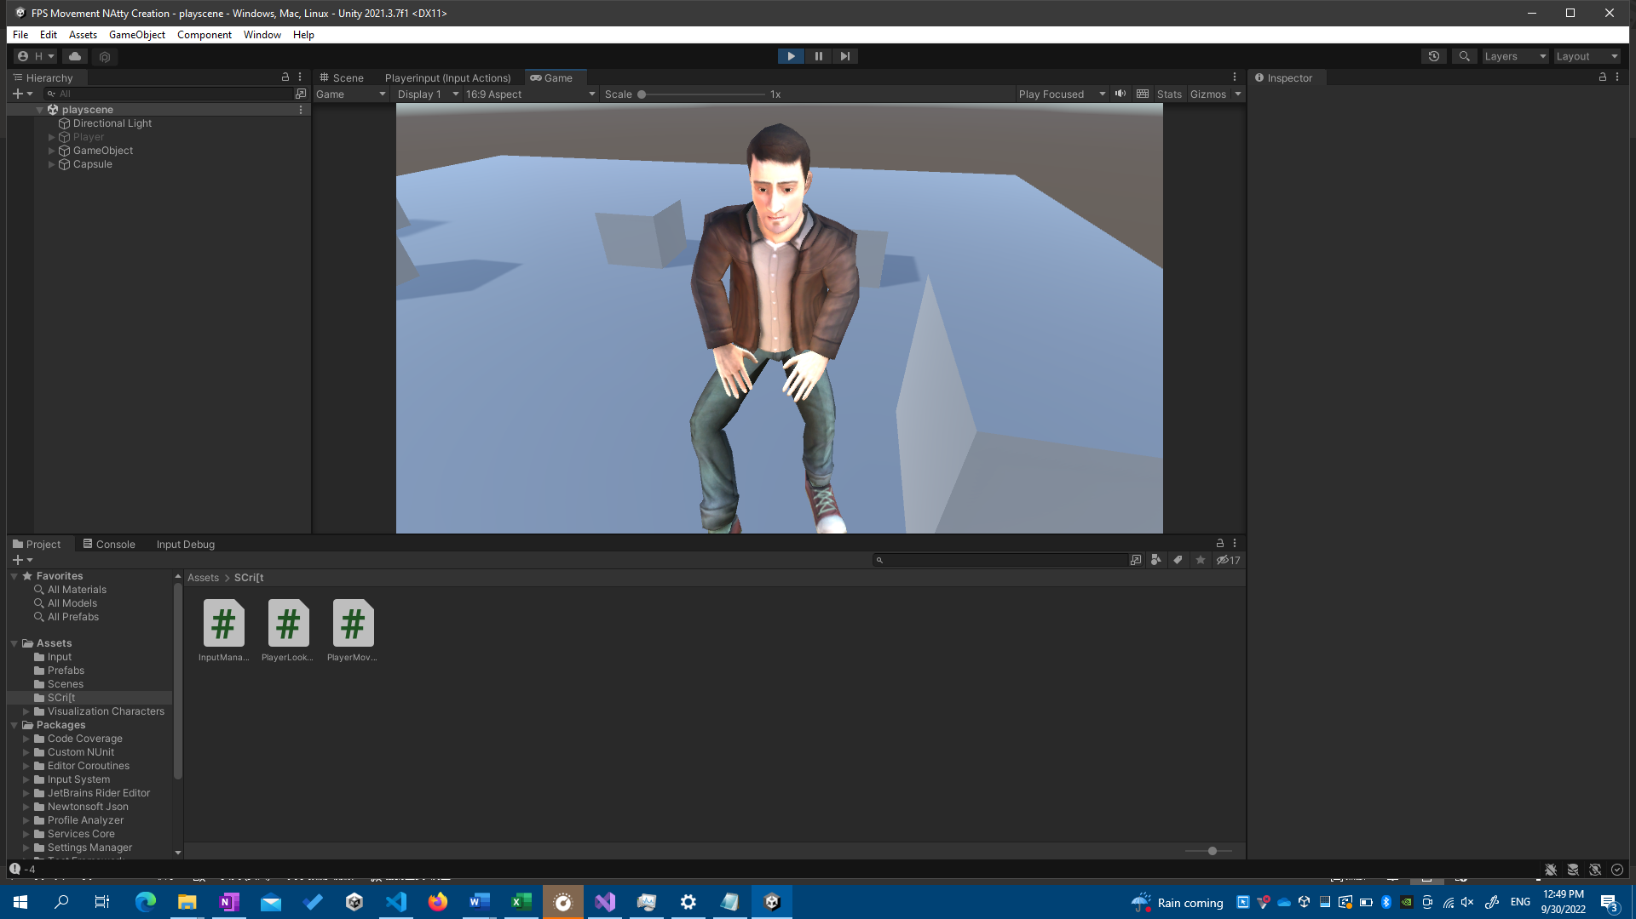

When I started coding my project, I need to get comfortable with the tools, which involve the C# language and the Unity Engine. In order to move and gaze about, I have followed a lesson on movement control using a computer mouse and keyboard (W, A, S, D, and spacebar). To demonstrate what I learnt from the instruction, I have also implemented a jump action. When a movement, such as walking or jumping, was triggered, animation was added and altered. To make a seamless transition, I utilised Unity's built-in Finite State Machine for Animator.

1. maze game (PC)

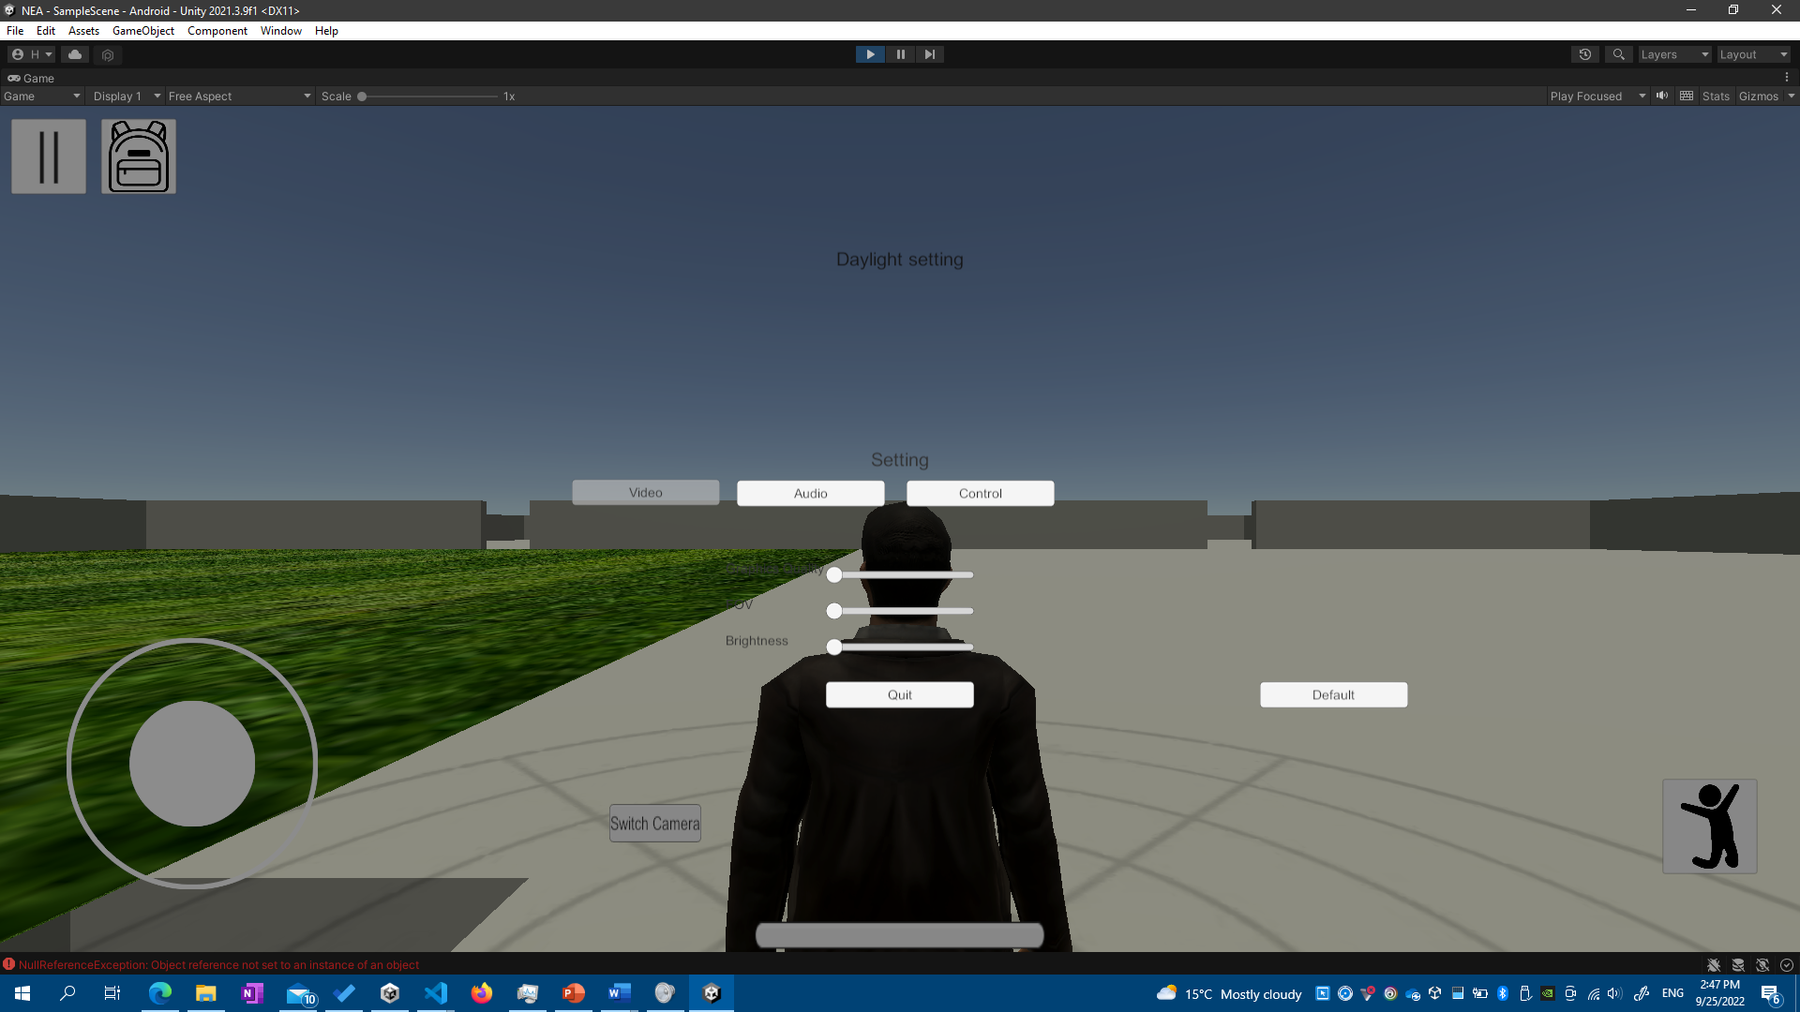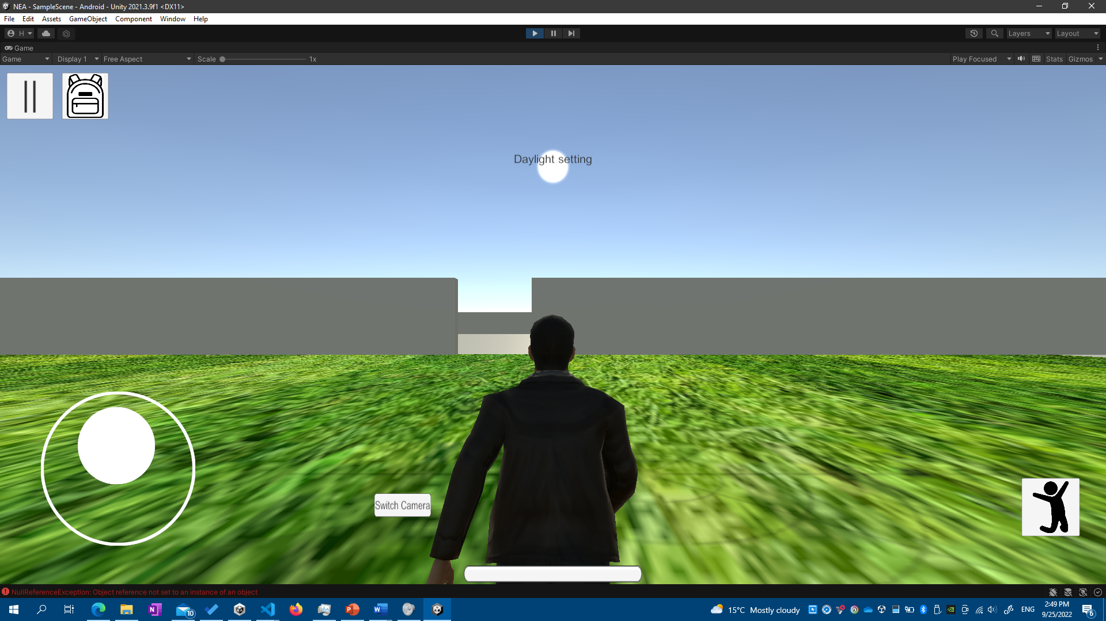

This is my 3D labyrinth game prototype. This map was created using the modelling software SketchUp. The model had been successfully imported into Unity. Except for the texture, the model is totally compatible with Unity Engine. However, a native Unity model needed to be replaced so I may apply texture to different parts of the model. This prototype includes the Main Menu, Pause Menu, Login and Registration Menu, and Inventory UI. This basically entirely covers the Interface of my game.

The setting function for customising the game in player presence is operational. There are multiple tabs for various setting categories. The joystick size and rotation sensitivity may be adjusted using the slider. To make this game mobile device suitable, the movement is modified from the sample game, and a joystick and detect screen touch input are added to make the game more touch-friendly. The joystick allows the character to move/walk and spin around by moving inside the right half of the screen. The prototype game, like the demo game, has animation.

## 1.2.10 Analysis Data Dictionary/ Possible Variable & Methods

|  |  |  |  |  |  |
| --- | --- | --- | --- | --- | --- |
| Field Name | Field Purpose | Field Type | Field Size | Example Data | Validation |
| Record_ID | Index of all data | Int | 11 | 0,1,2 | Primary Key, Unique |
| email | The login detail of user | String | 255 | [admin@shalev.ml](mailto:admin@shalev.ml) | Not blank, Unique |
| password | Login to verify user | Varchar | 255 | Ss12354678 | Not Null |
| username | Display playerName on leaderboard | String | 255 | Shalev Lau | Not Null, Unique |
| levelName | The level name | string | 50 | Easy | Not Null |
| multiplier | The reward of difficulties | float | 11 | 1.4 | Not Null |
| score | The number of monster player has killed | Int | 11 | 8 | Not Null |
| time | Time required to solve the maze | int | 11 | 50 | Not Null |

## 1.2.11 Data File Size /Volume

## 1.3 Specific Objective //measurable //achievable //validation – should need

### 1.3.1 Splash Screen

1. The name of the game should be appeared before the game start
2. The name of the producer should be appeared before the game start
3. A warning of copyright of the game needed to be shown in the loading screen
4. A Loading Screen should be showed after the names above is shown
5. Loading Screen needs to be clickable after the names shown
6. Main Menu should be loaded after the loading screen is clicked

1.3.2 Main Menu

* + 1. A introduction image should fade out before the Main Menu is shown
    2. A pop-up screen should be pop up to alert player to login to save the progress into the Leaderboard
    3. There should be 5 buttons on the screen, including Continue, Start Game, Leaderboard, Setting and Quit
    4. All 5 buttons listed in 1.3.2c should be able to open different panel when clicked
    5. The continue button should be disable if the game haven’t run before
    6. Login state should be on main menu remind the player which account it is logged in

1.3.3 Setting Screen

* + 1. Login Screen should pop up to convenience people to login
    2. The Setting Screen should have 5 categories, including Audio, Video, Control, Graphics and Login
    3. All 5 categories tabs listed in 1.3.3b will show corresponding setting category
    4. Default value should be set before if setting is never open/ configured before
    5. Video Option should contains the Field of View of camera and minimap setting
    6. Audio Option should contain SFX and Music Volume Setting
    7. Graphics Option should contain settings of Quality level and brightness
    8. Control Option should contain settings of the size of joystick and Sensitivity of turning around
    9. Settings value should be loaded after the Setting Panel is closed
    10. Value of settings should be saved in order to retrieve on next game runs

1.3.4 Quit Panel

* + 1. The quit panel should show 2 buttons including Quit Button and a Cancel Button
    2. The game should be quitted after Quit Button mentioned in 1.3.4a is clicked
    3. When cancel button is clicked, quit panel is disabled and return to main menu

1.3.5 LeaderBoard

* + 1. A leaderboard panel and 4 selection columns including player username, level, score and time used needs to be available for player click
    2. An instruction will pop up talking about the sorting and statistic player can access
    3. Different column will be sort using merge sort based on user selection
    4. Leaderboard data need to be automatically update

1.3.6 Login & Register

1.3.6.1 Login

1.3.6.2 Register

1.3.6.3 Welcome back

1.3.6 Level System

1.3.7 Start Game Save Slot Selection Panel

Pop up will show the detail of last play and the current score and time used to spend on the game

Game Save Status can be delete through a cross button and the continue button will be disable if deleted successfully

Game will start when either slot is clicked either going to animation or gameplay

1.3.8 First Time

Switch between the 1st and 3rd person camera

GameSave

Player Position

Maze location/ layout need to stay the same as previous game session

1.3.9 Inventory

A inventory panel should be open when

Search

Sort

Craft

Support undo crafting

Achievement system is available to reward player who achieve hardly achievement item

Notification

Pop up and banner notification

Pickup

When the player enter to the item trigger a

Item drop

Item pickup

Combat

Player

Player throw axe

Player can also set a trap

GamePlay UI

There should be a mini-map, time of the day, maze opening sequen in the gameplay UI

Pause

The time counter should be paused

There should be 3 buttons in the pause menu continue, setting and Quit

The pause panel should be disappear when continue or quit button is clicked

Quest System

Save and Load

The login state should be saved and login when the game restart

The player progress and earning should be saved and load when game reopened

The last gameplay session is saved to let player to continue the game

Power-Up

There should be few power up as a reward to player, including increased speed, extended health and stronger attack damage

Daylight system (Time)

The Maze Close everynight and open at 6.am

The time is available on screen display

1.3.10 Monster

The monster can route the maze using shortest path algorithms

Drop loot, rare item when dead

Throw Poison splash on player

Random type of monster spawn every day

1.3.11 Maze generation

A walkable path should be appear in the gameplay

1.3.12 Path finding algorithm

Randomise algorithm between A* algorithm

Login & Register

`Blood effect

To register, the user must enter

Quest system Q

Show monster health on their head

Save Load

## 1.4 Additional Objectives

Creative survival using the maze gate to trap and kill the monster

Blade should appear in the game

Lift animation

Achievement of player for killing the first griever or certain amount of monster

Ghost System

A splitting of player itself is replaying the progress of last game. To make a comparison and beat the old score

Multiplayer

FootPrint

Powerup

Speed

Health increase

Strength deal more damage

Music

Health

Take damage after attacked by the monster

Undo system

Online service

OAuth Automatic login with google play service

Backup game to google drive

Share on social media

Rewards

Bonus box at game start

Reward fir daily login

UI

Killcount

## 1.4 Proposed solution

My project will be implemented by C# and Unity Engine using Visual Studio Code and Jetbrain Rider as my IDE. Unity Engine is a powerful tool to create either 2D or 3D game and interchangable. Secondly, C# and Visual Basic shares the same library using Microsoft .NET framework which the syntax and logic is similar, so it is easier for myself to learn C#. Thirdly, Unity support multi-platform like android and WebGL so I don’t have to switch engine to switch platform. Thirdly, there are a lot more tutorial and resource for Unity compared to other game engine like Unreal Engine.

# 2. Design

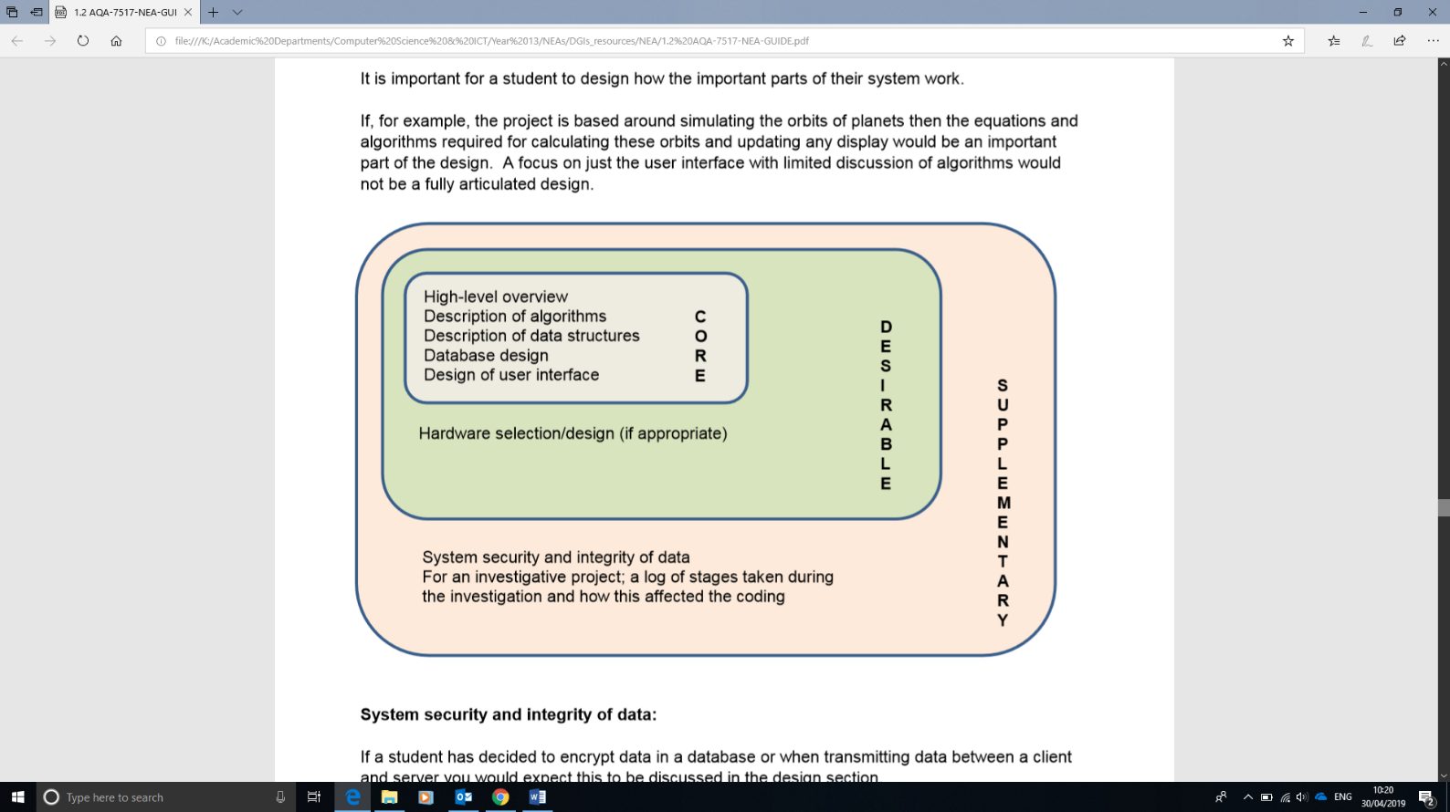

## 2.1 High-level overview

### 2.1a System flowchart

### 2.1b Class diagram

### abstract classes and interfaces inheritance

Aggeration & Composition

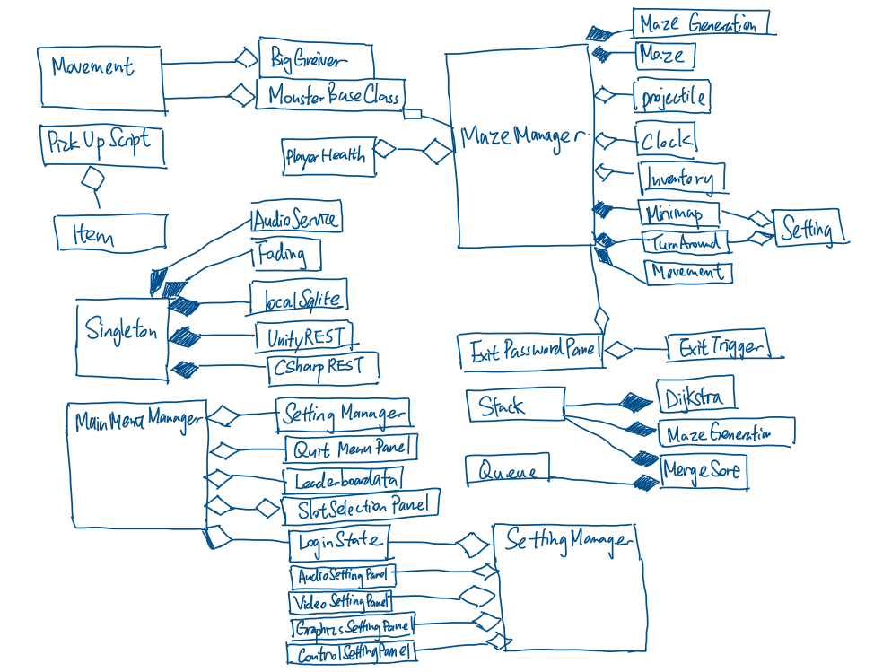

2.1c Data Flow Diagram

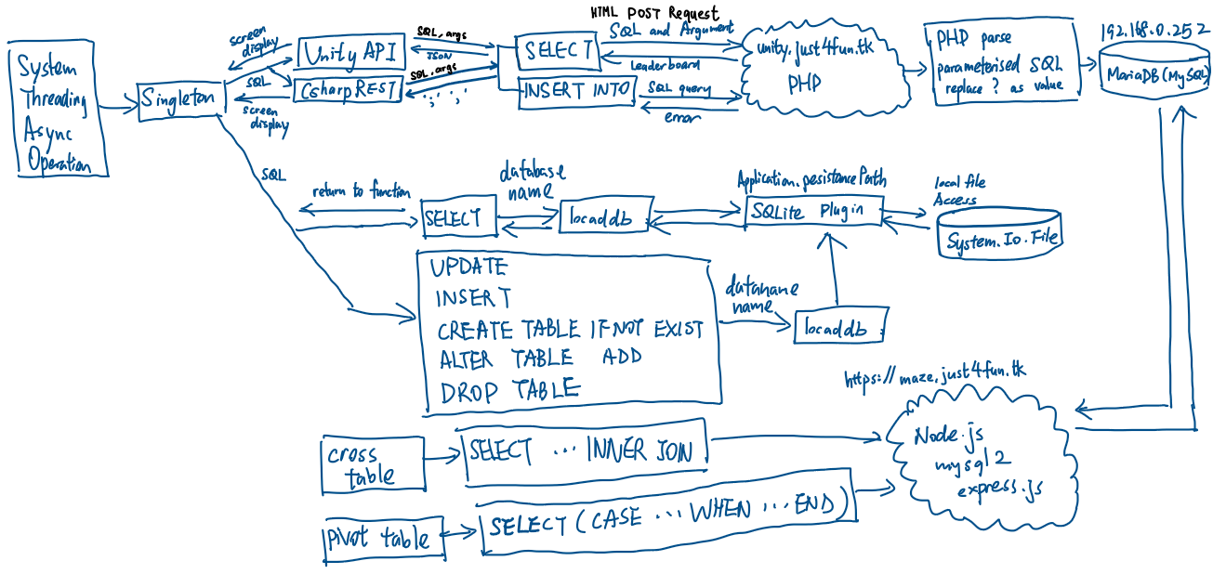

2.1d Site Map

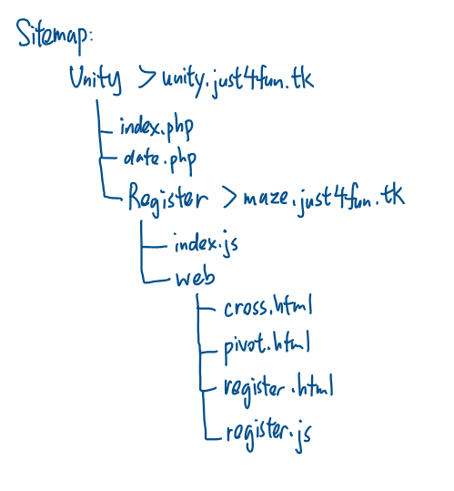

2.1e System chart

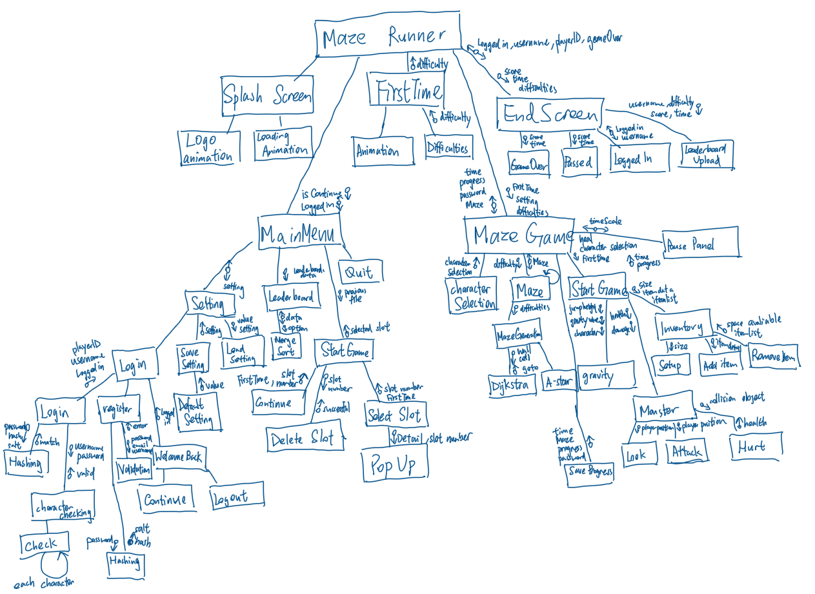

2.1d Table of Class

Algorithm

this folder contains all useful algorithms such as sorting and hashing and create a new instance to use the algorithm

|  |  |  |  |
| --- | --- | --- | --- |
| Class | Description | Attributes | Methods |
| BinarySearch | This class is contains a binary search function. It is easy to create a new instance and run as a searching service. |  | Search() |
| Checking |  |  | Check() |
| CQueue |  | _queue :int []  _circular :bool  _frontofqueue :int  _rearofqueue :int  _numberofitem :int | CQueue()  Enqueue()  Dequeue()  Peek() |
| gravity |  | _grounded :bool  gravityacceleration :float  _jumpgravity :float  _gravityspeed :float  _orginal :Vector3  _isUpJumping :bool | Update()  gravitySetting() |
| hashing |  |  | Convert()  HashTable() |
| lList |  | dataNmemoryloc :int  Headloc: int | lList()  AddHead()  GetNextPointer()  GetBlockData()  AddFoot()  Search()  Traversal()  SearchPriority()  AddWithPriority()  AddValue() |
| MergeSortAlgo |  |  | MergeSort()  Merge() |
| Projectile |  | Yacc  Speed  Gravity  Velocity | Update()  Shoot() |
| Stack |  | _stack_arr :object[]  _pointer :int | Stack()  Push()  Contains()  Pop()  Peek() |

|  |  |  |  |
| --- | --- | --- | --- |
| DifficultyPanel |  | Diffi : Slider | Start()  Load()  Update() |
| FirstTimeMan |  | Loader :GameObject  _animator :Animator | Awake()  Update()  LoadScene() |

Maze Scene

|  |  |  |  |
| --- | --- | --- | --- |
| CharacterDataBase |  | Characters :characterSpecification[]321 | GetGameObject() |
| characterSpecification |  | charImage :Sprite  charName :string  charDescription :string  speed :float  InventorySize :int  actualObject :GameObject |  |
| Charcard |  | Popup :Button  Selection :Button |  |
| Inventory |  | InventoryItem :Structure  itemDetail :item  quantity :int  inventoryItems :InventoryItem[] | Start()  Setup()  Pickupitem()  Removeitem() |
| Item |  | maxStack :int  itemImage :Image  obj : GameObject  itemName : string  Weight :float  Damage :float  Weapon :bool  Throwable :bool  Shootable : bool  pickupScript : PickUp  triggerradius : float | OnEnable()  OnTriggerEnter()  OnTriggerExit() |
| ItemsObject |  |  | Start() |
| Slot |  | mainSlot :bool  itemdetail : item  stacksize :int  stacksizeUI :TMP_Text  itemImage : Image  frame : Image |  |
| Djk |  | Wall: List<string>  Cell :MazeCell[]  Unvisitedcell | Djkinit()  Search()  Calcost()  Obcheck()  Sidebar()  AvaliableCell |
| Goto |  | Shouldmove :bool  Pos: Vector2  Speed :float  Hello : GameObject | Goto()  Update()  Move() |
| Grid |  | Width :int  Height :int  Gridarray :int[,] | Grid() |
| Maze |  | _sizeX :int  _sizeZ :int  _cellPrefab :GameObject  _walls :List<string>  _cells :Mazecell[,]  _wallPrefab :GameObjectq | Generate()  CreateCell() |
| Mazecell |  | Visited :bool  Dir : List<string>  Djkmincost :float  Djkprevious : Vector2  Djkvisited : bool  djkdirX : int[]  djkdirZ : int[]  ghost :float  hcost :float  fcost :float  Aprevious :Vector2  Avisited: bool  Adir: bool[] |  |
| MazeGeneration |  | _myParent : Transform  Wall : List<string>  Cell : Mazecell[,]  Stack1 :Stack | Run()  BuildMaze()  Checkdir() |
| mazegenerationWithStack |  | Cell : Mazecell[,]  Stack1 : Stack  Startx : int  Startz : int  Endx : int  Endz : int | mazegenerationWithStack()  Run()  Notify()  BuildMaze()  Checkdir() |
| WallCell |  |  | Start()  Update |

Monster

|  |  |  |  |
| --- | --- | --- | --- |
| BigGreiver |  |  | Update() |
| Blade |  | rotateSpeed : float  Scale : float | Start()  Update()  OnCollisionEnter() |
| IMonsterConfig :interface |  | Health: float  Location : Transform | Look()  Chase()  Dead() |
| MonsterBehaviour |  | _health : float  _location : Transform  _monsterloc : Transform  char1: GameObject  _animator :Animator  isDead : bool  isRunned :bool  _ins : MazeManager | Awake()  Start()  Update()  Look()  Chase()  OnCollisionEnter()  Dead() |
| SilverFish |  |  | Start() |
| SmallGriever |  |  |  |
| Movement |  | Joystick :Joystick  Move : Vector2  Wallspeed : float  isCrouching : bool  crouchwalk : float  crouchheight :float  jumpheight: float | Start()  Update()  Touchmovement()  Crouch()  Jumpbutton() |
| PlayerAction :Interface |  |  | PlayerMove()  PlayerLook() |
| PlayerSetup |  | Timer : float | Start()  Update() |
| Switchcam |  | _cams :Camera[] | ChangeCamera()  Start()  Update() |
| toucharea |  | Touch :GameObject | Start()  Update()  Raycast()  GetTouch() |
| Turnaround |  | _cam :Camera  Dyn_joy : Joystick  xSpeed :float  ySpeed :float | Start()  Update() |
| Circular |  | Center :Vector2  Radius : float  StartingPoint : Vector2  meterWidth: float  repeat :float  angle :float  objectToRotate: GameObject  rotationPoint :Vector3  rotationSpeed: float | Start()  Rotate() |
| Clock |  | Light :Light  Rotate :Vector3  Time :float  Text :TMP_Text  Date :int | Start()  FixedUpdate() |
| Escapecontroller |  | Time :TMP_Text  Monster : TMP_Text  Difficulties : TMP_Text  gameOverPanel : GameObject  PassedPanel :GameObject  mainPanel : GameObject  loginPanel :GameObject  CloseButton : Button  Username : string | Start()  Update()  Upload()  ContinueButton()  Back() |
| exitTrigger |  | Exit: GameObject  passwordPanel : GameObject | OnTriggerEnter()  DestroyWall() |
| gameOver |  |  | OnTriggerEnter() |
| Heal |  |  | Start()  Update()  OnTriggerEnter() |
| mainCharacter |  | currentSlot |  |
| MazeManager | his is the main function controlling most of the function of the game. Including saving and loading progress, maze generation and | characterUI : GameObject  empty : GameObject  characterSelectionUI : GameObject  mainchar : GameObject  cams :List<Camera>  player :GameObject  character : characterSpecification[]  currentselection : int  currentAttackSelection :int  selectcharButton :Button  invent :Inventory  _angle : int  _monsterKilled : int  Open_gate_order : CQueue  Opennow:bool  Playerpos :Vector3  _setting :Setting  _password : string  Sprites : Sprite[]  spriteSlot1 :Sprite  spriteSlot2 :Sprite  attackSelection : Image  startAt : TMP_Text  NextGate : TMP_Text  Nextmonster : TMP_Text  Counting :TMP_Text  monsterPrompt :TMP_Text | Dead()  spawnMonster()  Awake()  MonsterPrompt()  Start()  ShowCharacterPopUp()  Selection()  Maze()  StartGame()  OpenPassword()  FirstTime()  SaveLevel()  Attack()  changeAttack()  heal()  openGate()  Back()  UpdateScore() |
| Minimap |  | Minimap_cam :Vamera  Texture :RenderTexture  Img: RawImage | Setup() |
| onLoadMaze |  |  | Awake()  Update() |
| Open_gate |  | M_left: Transform  M_right: Transform  Back; Transform  Open: bool  Speed: int  mVecRIght_OpenPos: Vector3  mVecRIght_ClosePos: Vector3  mVecLeft_OpenPos: Vector3  mVecLeft_ClosePos: Vector3 | Update() |
| passwordPanel |  | Inputtext :TMP_InputField  Password :String  Done :bool | Start()  Update() |
| Pause |  | Leader : LeaderBoarddata | Awake()  Start()  Update()  timeChange()  Open()  Close()  SettingPause()  LeaderboardPause()  Back() |
| PerlinNoiseMap |  | Width: int  Height :int  Scale :float  Persistence :float  Lacunarity : float  Octaves : int  noiseMap: float[,] | Start()  Generate() |
| PickUp |  | Items : List<Item>  _selectionSlot:PickUpSelectionSlot | Start()  Update()  Toggle |
| PickUpSelectionSlot |  |  | Start()  Toggle() |

MainMenu:

|  |  |  |  |
| --- | --- | --- | --- |
| MenuPanels |  | _menu :GameObject | Awake()  Start()  ShowHide()  Function() |
| QuitMenuPanel |  |  | appQuit() |
| SlotSelectionPanel |  | filePath | Start()  SavefileSelector()  DeleteSlot()  popUpDetail() |
| AudioSettingPanel |  |  | Start() |
| ControlSettingPanel |  |  |  |
| GraphicsSettingPanel |  |  |  |
| Setting |  | Dbname :string  filePath :string  xSenS :Slider  ySenS :Slider  MusicVolS :Slider  sfxVolS :Slider  cameraFOVS :Slider  minimapSizeS :Slider  joystickSizeS :Slider  graphicQualityS :Slider  brightnessS :Slider | Start()  Setup()  LoadSetting()  SaveSetting()  UpdateSetting() |
| SettingManager |  | _audioPanel :AudioSettingPanel  _videoPanel :VideoSettingPanel  _graphicPanel :GraphicsSettingPanel  _controlPanel :ControlSettingPanel  buttonObject :GameObject  buttons :Button[]  path :TMP_Text | Start()  Login()  AudioAction()  VideoAction()  GraphicAction()  PanelHide()  QuitSetting() |
| VideoSettingPanel |  |  |  |
| LoadingCircle |  |  | Update() |
| SplashScreen |  | allowChange :bool | Start() |
| continuePanel |  | continueButton :button | Start()  ClosePanel() |
| Leaderboard/ leaederslot |  | Username :string  Level :int  Score :int  Since :int |  |
| LeaderBoarddata |  | Slot :Transform | External()  Start()  Sorting()  ParseJSON()  WebLeader()  GetData()  printData() |
| loginState |  | loginButton :Button  emailField :TMP_InputField  passowrdField :TMP_InputField  info :TMP_Text  welcomebackPanel: GameObject  loginPanel :GameObject  notMeButton: Button  playButton :Button  getusername : TMP_Text  username : string  ID :int | Start()  OnEnable()  welcomeBack()  Play()  NotYou()  Register()  Login()  infoHandler()  hashFunction()  hexToDec() |
| MainMenuManger |  | _manSfxPlay :bool  _manAnimator :Animator  Fade :Image  _continuePanel :GameObject  menubuttonSfx :List<AudioClip>  manSfx : AudioClip[]  quitButtonSfx : AudioClip  menuButtons : GameObject  _menuSekectorButton : button[]  _settingManager : SettingManager  _quitMenuPanel : QuitMenuPanel  _leaderboardPanel: LeaderBoarddata  _slotSelectionPanel : SlotSlectionPanel  Panels : GameObject[]  _loginState: loginState  continueFrom :int  loginState: TMP_Text  continueButton: Button | Awake()  continuePrompt()  menuSelectorButtonAction()  Update()  PlaySound()  Move()  ShowQuit()  ContinueButton() |
| onLoadMainMenu |  |  | Awake()  Update() |

Universal/static : (Singleton)

Singleton is a script that set as a universal static script which means it can be accessed anywhere without decalacfed and implement the script, it wont be destroy in the whole game and only 1 singleton will be allowed as it is the “main controller/ Access Point” of the game. Singleton hide the complexity of the code by providing Function/Sub-routine for code that needs to be run repeatedly and because of the global scope of GameObject. Data inside Singleton can also act as a carrier to different scene to reduce the complexity of code.

|  |  |  |  |
| --- | --- | --- | --- |
| Singleton | This class allows only one single instance of itself and give access to that created instance  Used on abstract class will not physically in the game  Handle game menu and function button on screen and change currency and lives | fadeSpeed : float  LocalDB : localSqlite  UnityAPI: UnityREST  CsharpAPI: CsharpRESET  Fade: Fading  AudioPlayer: AudioService  HealthClass: playerHealth  LoadScreenclass: LoadingPanel  popup: PopUpPanel  _FirstTime : bool  _loadNumer: int  _instance :int | Start()  Init()  ShowDetail()  ShowError() |
| Sound Manager |  | _music :AudioSource  _sfx :AudioSource | OnEnable()  PlayMusic()  PlaySfx() |
| Pop up panel |  | _itemImage :Image  itemDescription: string  itemName: TMP_Text  Error :Sprite | Start()  ShowDetail()  ShowError() |
| Loading Panel |  | Progressbartext :TMP_Text  touchContinue :TMP_Text  Title :TMP_Text  LoadingCircle :GameObject  progressBar :GameObject  TouchButton :GameObject  loadScene : AsyncOperation  showProgressbar :bool  loadComplete :bool  WordList :List<string>  currentTitle :int  timePeriod :float | OnEnable()  LoadScene()  ChangeScene()  Update() |
| Player Health |  | HealthFront :Slider  HealthBack :Slider  HealthValue :float  chipSpeed :float  fillArea :Image  targethealth :float  time :float  increase :bool  decrease :bool | Update()  UpdateUI()  changeHP()  resetChange()  gameOverCheck() |
| Fading |  | fadeSpeed :float | FadeIn()  FadeOut() |
| UnityAPI |  |  | GetData() |
| CsharpAPI |  |  | GetData()  PostData() |
| SQLiteDB |  | Path :string | Init()  Query()  WhenFileCreated() |

### 2.1d Variable declaration of Main Algorithm

|  |  |  |  |
| --- | --- | --- | --- |
| Class Name | | Login_state | |
|  | Name | Data Type | Comment |
| Private |  |  |  |
| public | Monster | Queue |  |
|  |  |  |  |

## 2.2 Modular in structure of system

### 2.2a Structure chart /Site map

Paragraph of how your game will work

### 2.2b IPSO

|  |  |  |  |
| --- | --- | --- | --- |
| Input | Process | Output | Storage |
| Touch screen touch input | Random maze generation | Sound | Database |
| Touch screen swipe input | Transform swipe into movement and Turning around of character | Graphical user interface | Local storage(text, csv and binary) |
| On screen keyboard |  | The change of healthbar | Player position |
|  |  | The grid and the map | Player level |
|  |  |  | Player Health |
|  |  |  | Monster position |
|  |  |  | Username |
|  |  |  | Password |
|  |  |  | Player items |

## 2.3 Data Items & structures //Dynamic or fixed? How will it use heap?

I will use linked list for hash table sorting. Linked list uses a pointer to the end and point to the next memory location. New list data is allocate by the free available location in the heap. It is a dynamic data structure which is easily changeable in the size of the list. However, it can only access by the sequential/ traversal.

- how am I going to use itin my game

## 2.4 Database design (Normalised ER diagram

Player

Progress

Level

UNF:

Table (email, password, username, levelName, multiplier, score, time)

1NF:

Player(playerID, email, password, username)

Table(levelID, levelName, multiplier, score, time)

2NF

Progress(progressID, playerID, levelID, score, time)

Player(playerID, email, password, username)

Level(levelID, levelName, multiplier)

3NF is same as 2NF as there is no partial key dependencies

Update: password has been replaced by hash and salt for security issue mentioned in 2.13a

Progress(progressID, playerID, levelID, score, time)

Player(playerID, email, hash, salt, username)

Level(levelID, levelName, multiplier)

## 2.5 File Structure and Organisation

My database will use SQL Query. It is a direct access to indexed records

List out where data is stored

## 2.6 Identification of main algorithms //Use Structured English OR Pseudocode

### 2.6a A*

Djkstra

Hash table reverse a list using

### 2.6b Maze Creation

### 2.6c Linked List

### 2.6d Merge Sort

### 2.6e Binary Search

### 2.6f Daylight System

### 2.6g Inventory

### 2.6h Menu/ UI manager

### 2.6g Singleton (Audio)

## 2.7a Online Query

|  |  |
| --- | --- |
| Query Name | Login |
| Query Type | SELECT |
| Purpose | Check the Password of the user match with the value in database, if yes, apply username into the game |
| Table(s) | Player |
| Attribute(s) | hash, salt, playerID, username |
| Criteria | The email value that player entered |
| Display Method | Screen display |
| SQL | SELECT hash, salt, playerID, username FROM Player WHERE email = ?" |

|  |  |
| --- | --- |
| Query Name | BestScoreOfPlayer |
| Query Type | SELECT |
| Purpose | Get the players’ own best score |
| Table(s) | Level, Player, Progress |
| Attribute(s) | Player.username, Progress.score |
| Criteria | Player.playerID = Progress.playerID AND Level.levelID = Progress.levelID |
| Display Method | Screen Display |
| SQL | SELECT pl.username,  max(CASE WHEN l.levelID=6 THEN p.score ELSE NULL END) AS Level_3,  max(CASE WHEN l.levelID=7 THEN p.score ELSE NULL END) AS Level_4,  max(CASE WHEN l.levelID=8 THEN p.score ELSE NULL END) AS Level_5,  max(CASE WHEN l.levelID=9 THEN p.score ELSE NULL END) AS Level_6,  max(CASE WHEN l.levelID=10 THEN p.score ELSE NULL END) AS Level_7,  max(CASE WHEN l.levelID=11 THEN p.score ELSE NULL END) AS Level_8,  max(CASE WHEN l.levelID=12 THEN p.score ELSE NULL END) AS Level_9  FROM Progress p INNER JOIN Level l ON p.levelID = l.levelID, Player pl  WHERE p.playerID = pl.playerID  GROUP BY pl.username; |

|  |  |
| --- | --- |
| Query Name | TopScore |
| Query Type | SELECT |
| Purpose | See the Best Player And Best Time of each level |
| Table(s) | Level, Progress, Player |
| Attribute(s) | Time, levelID, score, pl. username |
| Criteria | Player.playerID = Progress.playerID AND Level.levelID = Progress.levelID |
| Display Method | Screen Display |
| SQL | SELECT l.levelName,  l.levelID,  COUNT(p.progressID) AS no_player, -- need count for item only  MAX(p.score) AS Best_Score,  (SELECT pl.username FROM Progress p, Player pl   WHERE p.playerID = pl.playerID AND p.score =     (SELECT MAX(score) FROM Progress p2 WHERE p2.levelID = l.levelID LIMIT 1)) AS Best_score,  MIN(CASE WHEN l.levelID BETWEEN 6 AND 12 THEN p.time ELSE 100000 END) AS Best_Time,  (SELECT pl.username FROM Progress p, Player pl   WHERE p.playerID = pl.playerID AND p.time =     (SELECT MIN(time) FROM Progress p2 WHERE p2.levelID = l.levelID LIMIT 1)) AS Best_time,  AVG(p.score) AS AVG_Score,  AVG(p.time) AS AVG_Time  FROM Player pl,Progress p,Level l  WHERE p.levelID = l.levelID AND p.playerID = pl.playerID  GROUP BY l.levelName  ORDER BY l.levelID; |

|  |  |
| --- | --- |
| Query Name | AllStat |
| Query Type | SELECT |
| Purpose | Show all gameplay statistics |
| Table(s) | Progress p, Level l, Player pl |
| Attribute(s) | pl.username,p.levelID, p.score, p.time |
| Criteria | Player.playerID = Progress.playerID AND Level.levelID = Progress.levelID |
| Display Method | Screen Display |
| SQL | SELECT pl.username,p.levelID, p.score, p.time FROM Progress p INNER JOIN Player pl ON p.playerID = pl.playerID |

|  |  |
| --- | --- |
| Query Name | UploadScore |
| Query Type | INSERT INTO |
| Purpose | Upload a score record to server |
| Table(s) | Progress |
| Attribute(s) | `playerID`, `levelID`, `score`, `time` |
| Criteria | N/A |
| Display Method | Not displayed |
| SQL | INSERT INTO `Progress`( `playerID`, `levelID`, `score`, `time`) VALUES (?,?,?,?) |

## 2.7b local SQLite Query in Save0/1/2.sqlite3

|  |  |
| --- | --- |
| Query Name | AddDifficultyColumn |
| Query Type | ALTER TABLE … ADD |
| Purpose | Add a “difficulty” column for storage preparation |
| Table(s) | GAMEDATA |
| Attribute(s) | Difficulty |
| Criteria | / |
| Display Method | Not displayed |
| SQL | ALTER TABLE GAMEDATA ADD difficulty INTEGER" |

|  |  |
| --- | --- |
| Query Name | InputDifficulty |
| Query Type | INSERT INTO |
| Purpose | Input the difficulty selection from the user |
| Table(s) | GAMEDATA |
| Attribute(s) | Difficulty |
| Criteria | / |
| Display Method | Not displayed |
| SQL | INSERT INTO GAMEDATA(difficulty) VALUES ({diffi.value}) |

|  |  |
| --- | --- |
| Query Name | DeleteGAMEDATA |
| Query Type | DROP TABLE |
| Purpose | Restart the level, remove the old entry |
| Table(s) | GAMEDATA |
| Attribute(s) | / |
| Criteria | / |
| Display Method | Not displayed |
| SQL | DROP TABLE IF EXISTS GAMEDATA",  $"Save{index}.sqlite3"); |

|  |  |
| --- | --- |
| Query Name | CreateGAMEDATA |
| Query Type | CREATE TABLE |
| Purpose | Create a new storage for progress save |
| Table(s) | GAMEDATA |
| Attribute(s) | / |
| Criteria | / |
| Display Method | Not displayed |
| SQL | CREATE TABLE GAMEDATA ('characterSelection' INTEGER, 'playerX' FLOAT, 'playerY' FLOAT , 'playerZ' FLOAT ); |
| Query Name | ProgressSave |
| Query Type | UPDATE GAMEDATA |
| Purpose | Save the progress time and monsterCount |
| Table(s) | GAMEDATA |
| Attribute(s) | / |
| Criteria | / |
| Display Method | Not displayed |
| SQL | UPDATE GAMEDATA SET time = {time}, monsterKilled = {mons} |

|  |  |
| --- | --- |
| Query Name | LoadProgress |
| Query Type | SELECT |
| Purpose | Load Previous Save Record |
| Table(s) | GAMEDATA |
| Attribute(s) | characterSelection, difficulty, monsterKilled,time,playerX,playerY,playerZ |
| Criteria | / |
| Display Method | Not displayed |
| SQL | SELECT characterSelection, difficulty, monsterKilled,time,playerX,playerY,playerZ FROM GAMEDATA |

|  |  |
| --- | --- |
| Query Name | SaveSelection |
| Query Type | UPDATE |
| Purpose | Save player Selection of main character |
| Table(s) | GAMEDATA |
| Attribute(s) | characterSelection |
| Criteria | / |
| Display Method | Not displayed |
| SQL | UPDATE GAMEDATA SET characterSelection = {currentselection}; |

|  |  |
| --- | --- |
| Query Name | AddexitColumn |
| Query Type | ALTER TABLE |
| Purpose | Create a column (field) for inputing exit_position data |
| Table(s) | GAMEDATA |
| Attribute(s) | Exit |
| Criteria | / |
| Display Method | Not displayed |
| SQL | ALTER TABLE GAMEDATA ADD exit INTEGER |

|  |  |
| --- | --- |
| Query Name | Initial Setting |
| Query Type | CREATE |
| Purpose | Setup a TABLE for storing Setting value |
| Table(s) | Setting |
| Attribute(s) | sfxVol, MusicVol, cameraFOV , xSen, ySen, joystickSize, graphicQuality, brightness, minimapSize |
| Criteria | N/A |
| Display Method | Not displayed |
| SQL | CREATE TABLE if not exists 'Setting' (  'sfxVol' INTEGER, 'MusicVol' INTEGER,  'cameraFOV' INTEGER, 'xSen' INTEGER,  'ySen' INTEGER, 'joystickSize' INTEGER,  'graphicQuality' INTEGER, 'brightness' INTEGER, 'minimapSize' INTEGER  ); |
|  |  |

|  |  |
| --- | --- |
| Query Name | Save Setting |
| Query Type | UPDATE |
| Purpose | Change the existing setting value to new value |
| Table(s) | Setting |
| Attribute(s) | sfxVol, MusicVol, cameraFOV , xSen, ySen, joystickSize, graphicQuality, brightness, minimapSize |
| Criteria | Attribute include (sfxVol, MusicVol, cameraFOV , xSen, ySen, joystickSize, graphicQuality, brightness, minimapSize) |
| Display Method | Not displayed |
| SQL | UPDATE Setting  SET sfxVol = {sfxVol},  MusicVol = {MusicVol},  cameraFOV = {cameraFOV},  xSen = {xSen},  ySen = {ySen},  joystickSize = {joystickSize},  graphicQuality = {graphicQuality},  brightness = {brightness},  minimapSize = {minimapSize}; |

## 2.8 Identification of Storage Media

The remote server will be store the data of progress, player info and level details by MariaDB whilst my local database will store the game state and generation of maze, login detail and settings using SQLite.

What am I using to connect /update the db

## 2.9 HCI Rationale rationale for choosing this

// A paragraph covering, for example, colour, font, size, type of interface (GUI? (menu, pull-down)), and your.

This game is a realistic 3D maze survival game, most of the asset in the game will be downloaded from the unity store. I want to make my game GUI and the menu looks fancier so I will use the font and the template of User interface. The colour is mostly gray and blue as it is the main colour palette in the movie maze runner

For the model and animation of the character and monster. Because of shortage of time and the skills, I have decided to import 3d model under CC license. As the game is designed for mobile user. All input is detected from touching of the screen including virtual keyboard for password entering, buttons are also enlarge for decreasing of the precision of finger touching

## 2.10 HCI Sample of Planned Input Design //storyboard //drawing of the sample game scene

Soundeffect multiplayer NPC appearance object hosse, farming, introduction

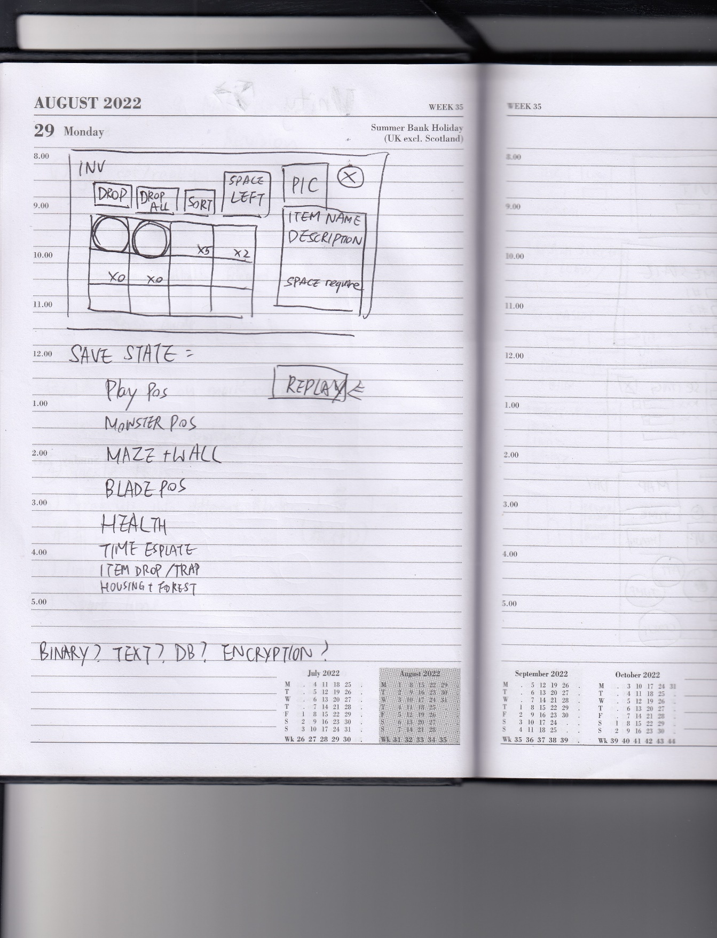 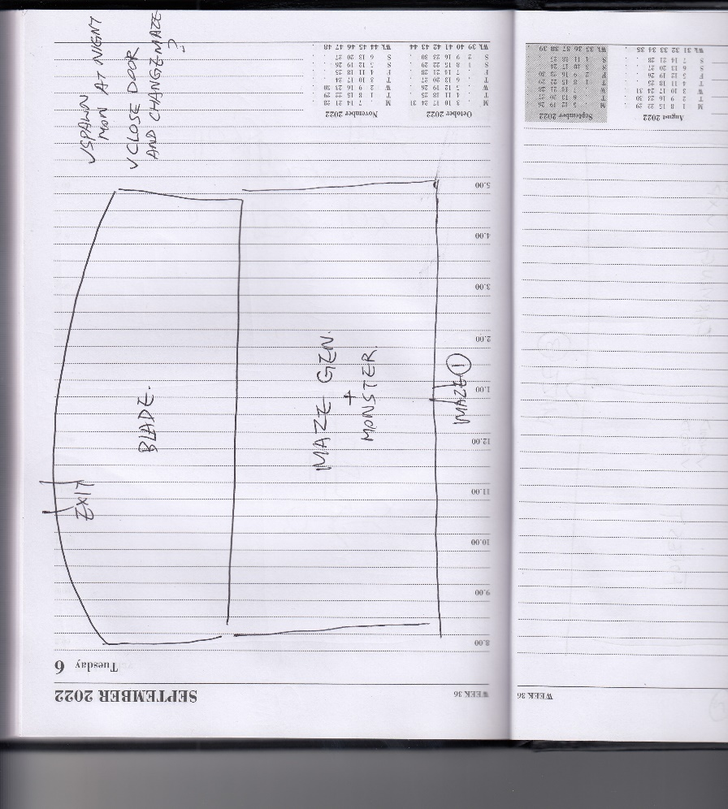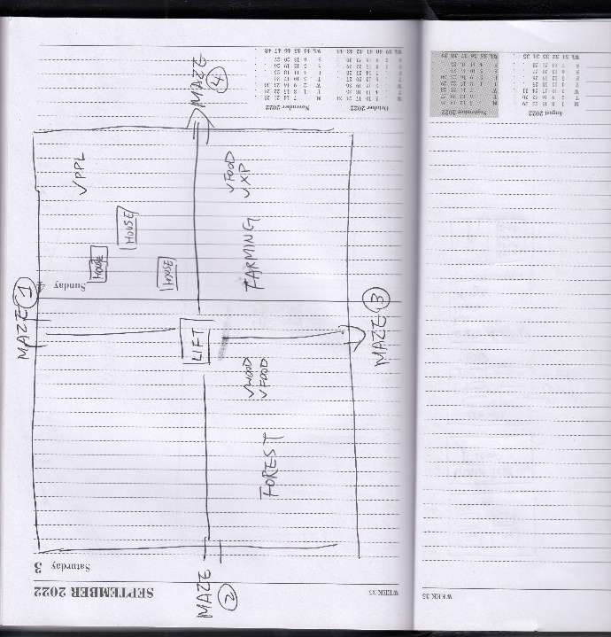 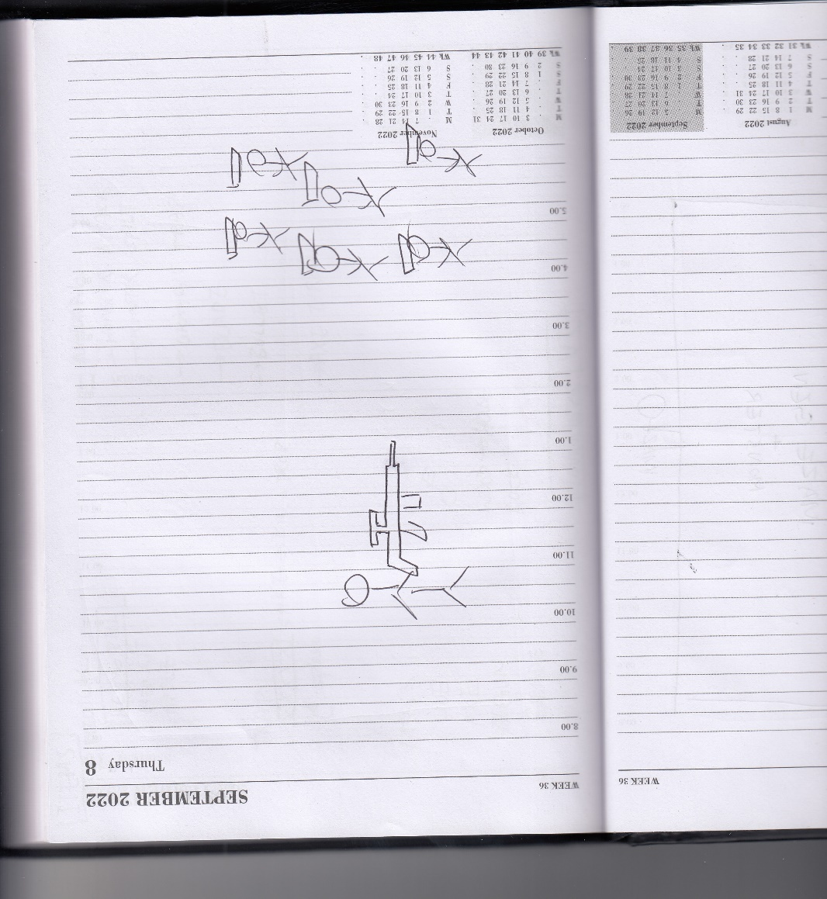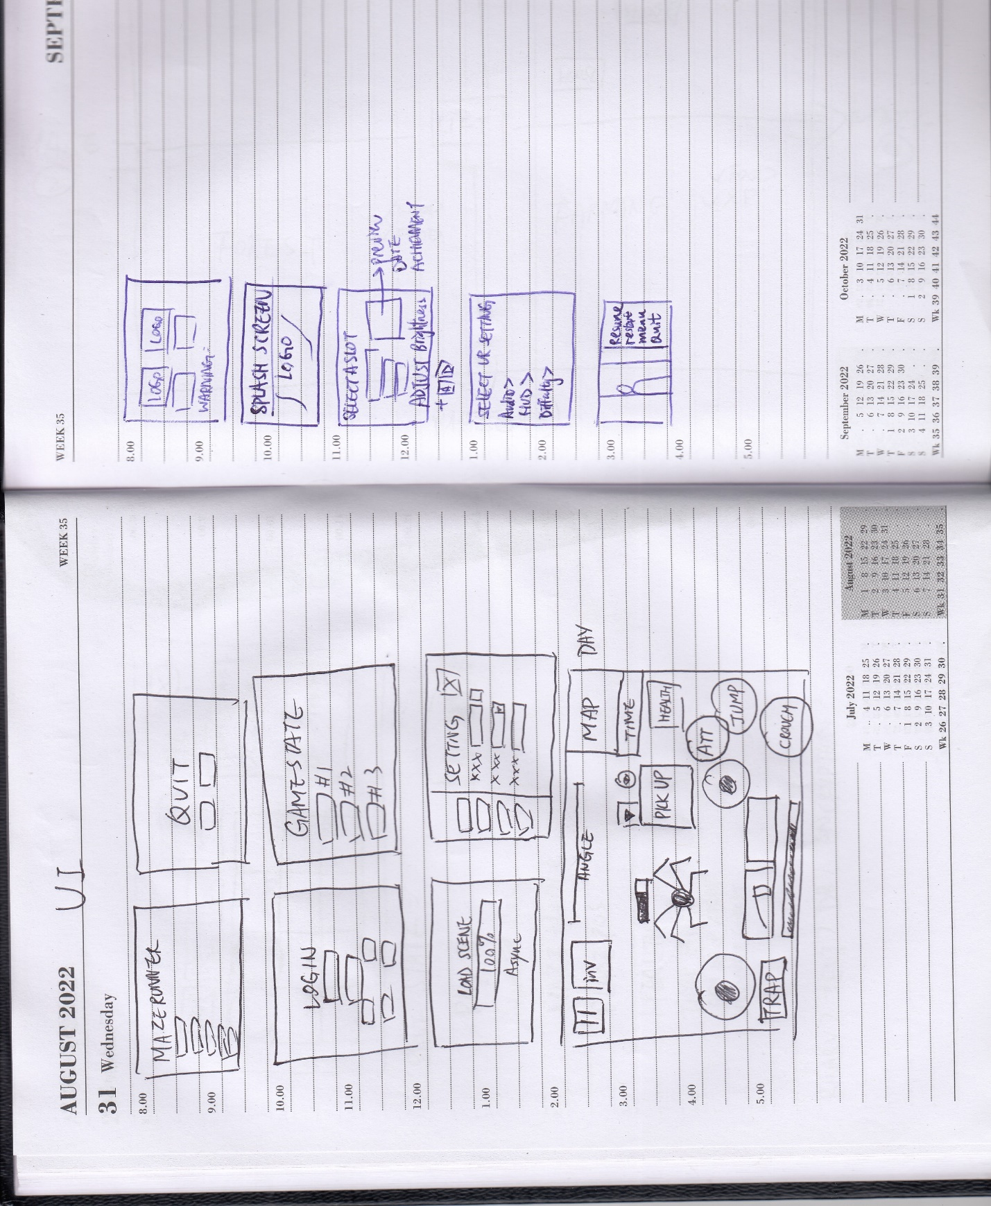 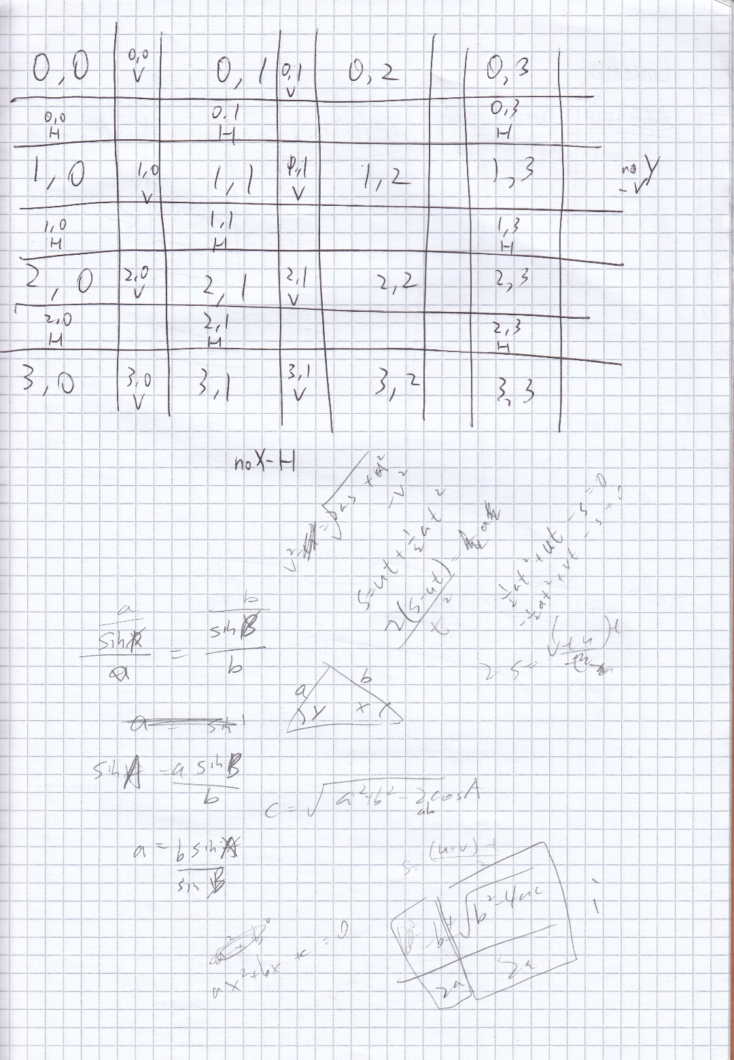

## 2.11 HCI planed output design

The user will have a choice of next level or

## 2.12 Hardware and Software requirement

A powerful phone which able to run 3D and complex graphics as the map of my game is quite large and include a lot of texture. It is essential to have a decent smartphone in order run this game smoothly. The file size of the game is also quite large due to the texture.

## 2.13 Description of measures planned for security and integrity of data

### 2.13a Security of the data

Although the leaderboard and login is able to access through the internet. However, both PHP and Node.JS are both backend programming language which normal user has no way to access the code so the database is secure from prevent unauthorised accses

### 2.13b Integrity of the data

The register website will sanitise the user input and prevent unwant character. Account will be verify by email One-Time Password to make sure the email address is correct and usable. Password will be stored in a form of hashing and salt data instead of plaintext which can improve the security of user password cracked by hacker

### 2.13c Access Control

A non-admin user is created to access the database with basic privileges including DDL, DML and DQL query only. The password used Upper and lowercase letter, numbers and symbol to form at least 12 digit. The time complexity of cracking the password is O(n!). which is impossible in a lifetime in brute force method.

## 2.14 System security

There is a risk of being SQL injected by hacker using ‘WHERE user =””’ . To prevent this, all field is sanitise with character checking algorithm and parameterised query is used to prevent SQL injection.

## 2.15 Overall Test Strategy //how you conduct a test + user acceptance

I am going to use a white box testing for my game as it doesn’t have any invalid input from a touch screen devices

- test evaluation

I am going to use White-box testing for my whole game because I am creating a game for mobile phone, which every touch on the phone is valid. Even though user click on the GameObject that without a Touch Listener, the input still count as valid.

1. test evaluation, prove the game is working, opening order and the maze generation is random and able to continue with the state saved

I am going to use black-box testing to test the register validation and login validation using boundary and wrong data to prove it stop invalid input of account register or login

# 3.0 Technical Solution

All script is attached into a separate folder which is

|  |  |  |  |  |
| --- | --- | --- | --- | --- |
| Skills | | | | Page |
| >=3 tables interlinked |  | |  | See 2.4 for E-R diagram |
| Cross-table SQL |  | |  | 110 (Section 2.7a TopScore) |
| Pivot SQL |  | |  | 110 (Section 2.7a BestScoreOfPlayer) |
| DDL scripts |  | |  | 84,88,12,23,27,28,17,85 |
| DDU script |  | |  | 110,18,22,23,27,28,30 |
| Hashing |  | |  | 5, 77, 110 |
| Lists | built-in | |  | 6,7,19,23,24,36,4344,48,49.51,72,73,79,96 |
| Stacks | Self-made | | 10 | 44,51-54 |
| Queues | self-made | | 2 | 20,24,29 |
| Graphs |  | |  | Tree + Merge sort |
| Trees |  | |  |  |
| Recursion (In maze generation) |  | |  | maze and djk |
| Dijkstra algorithm | Self-made | |  |  |
| Merge sort | Self-made | |  | 7,8,71 |
| Abstract classes, interface |  | |  | 58,66 |
| Encapsulation |  | |  | 3,4,20,30,32,39,41,49,51,51,52,58,62,72,79,102,103 |
| Inheritance |  | |  | 11,36,37,38,71,74,79,80,83,85,86,89,91.95,99,9,62, |
| Composition | |  |  |  |
| Polymorphism | |  |  |  |
| Interfaces | |  |  | monsterbehaviour |
| Server side scripting using request and response objects.(PHP and Node.JS) | |  |  | 108,109,110,111 |
| Calling parameterised APIs  Parsing SQL Query Result | |  |  | 104, 107 |
| SQLite localdb | |  |  | 105 |
| File handling | | Built-in |  | 16,17 |
| Multi-dimensional arrays | |  |  | 6,35,43,48,49,51,52,54 |
| Binary search | | Self-made | 1 |  |
| Text and binary file | |  |  | 75,76,80 |

# 4. Testing – Testing is completed or not

Youtube Video()

4.1 Testing method

According to the test strategy I have planned

White-box testing

Black- box testing

Screenshot

As I have use present tense

1. White box Just the maze working
2. Black box test plan

The table

As I showed in tge design

|  |  |  |  |  |  |
| --- | --- | --- | --- | --- | --- |
| **Test No** | **Test Description** | **Test Data** | **Expected Outcome**  **(future tense** | **Actual Outcome (past tense** | **Comments** |
| **1** | Logo screen |  |  |  |  |
| **2** | Touch- loading screen |  |  |  |  |
| **3** | (with sound) |  |  |  |  |
|  | Pop up appear |  |  |  |  |
|  | Main menu with 5 button |  |  |  |  |
|  | Animation |  |  |  |  |
|  | Logi state |  |  |  |  |
|  | In setting open successfully |  |  |  |  |
|  | Login screen automatically pop up |  |  |  |  |
|  | Blank username and password |  |  |  |  |
|  | Password length must be longer than 8 char |  |  |  |  |
|  | Username must not be blank |  |  |  |  |
|  | Check login password match record |  |  |  |  |
|  | With wrong username and Password |  |  |  |  |
|  | And correct password to login |  |  |  |  |
|  | Login success info showed |  |  |  |  |
|  | Login state update |  |  |  |  |
|  | Welcome back panel showed |  |  |  |  |
|  | Not me will sign out |  |  |  |  |
|  | Login state update |  |  |  |  |
|  | Audio setting panel open successfully |  |  |  |  |
|  | Setting change |  |  |  |  |
|  | Leaderboard panel open successfully |  |  |  |  |
|  | Leaderboard pop up instruction |  |  |  |  |
|  | Control setting panel and Sensitivity value change successfully |  |  |  |  |
|  | Leaderboard data shown with sorted selected column |  |  |  |  |
|  | cross table and pivot open on external browser |  |  |  |  |
|  | slot selection panel show up |  |  |  |  |
|  | pop up show the last access date (detail |  |  |  |  |
|  | Slot Delete with cross button |  |  |  |  |
|  | When clicked load scene |  |  |  |  |
|  | Animation of fT start |  |  |  |  |
|  | After finish play, |  |  |  |  |
|  |  |  |  |  |  |
|  |  |  |  |  |  |
|  |  |  |  |  |  |
|  |  |  |  |  |  |
|  |  |  |  |  |  |
|  |  |  |  |  |  |
|  |  |  |  |  |  |
|  |  |  |  |  |  |
|  |  |  |  |  |  |
|  |  |  |  |  |  |
|  |  |  |  |  |  |
|  |  |  |  |  |  |
|  |  |  |  |  |  |
|  |  |  |  |  |  |
|  |  |  |  |  |  |
|  |  |  |  |  |  |
|  |  |  |  |  |  |
|  |  |  |  |  |  |
|  |  |  |  |  |  |
|  |  |  |  |  |  |
|  |  |  |  |  |  |

Corrective action

1. Black box test evidence
2. Proper user-User acceptance testing
3. Video

Timestamp// sound// video link for youtube

1. 15 test audience

My game should only played by over 14 as it contains blood effect and requires logical skills to control the game

# 5. Feedback and Evaluation

## 5.1 User Feedback

### 5.1.1 Positive comment I have got is:

“The maze is easy to navigate”

“simple to understand and joystick easy to use”

“The map wasn’t very hard to navigate with difficulty level of 6”

“Pretty cool game especially if you like the game Maze Runner”

“The game is quite straight-forward”

“This game is excellent”

“I liked the mini-map”

“Easy to navigate the maze”

“randomised gate opening was very good”

“The graphics and animation is cool”

### 5.1.2 The negative comment:

“Did see through the wall and lagged a bit”

“The XBOX controller is not human”

“registration in game doesn’t work”

“The wall were difficult to open”

“No introduction to explain how the game works”

“The password of the gate is difficult to understand”

“Not too much Maze Runner content inside the game”

## 5.2 Objective Feedback

### 5.2.1 Bugs that player has encountered is

“login doesn’t work”

“When crouching the game crashed”

“after starting of the game there was a loading screen bug”

“glitches when creating a new account”

“Crashes after game animation”

“Could have a better User Interface ”

“couldn’t exit the login/register page”

“invisible wall has been identified”

“when the game is load, the weapon icon is a white square”

“The animation of the player in 3rd person perspective”

## 5.3 Improvement and extension

### 5.3.1 The improvement comments that player has given is:

“Make the game first person exclusively as the animation is not complete”

“The texture of the maze could be improved”

“Tutorial stage is better to be added in to explain the mechanics and controls”

“Setting Panel could be added in pause screen”

“Monster could be despawn after death/ time based despawn”

“A stamina zbar for character to sprinting and make crouch as default (lower speed)”

“Make a crosshair in the game for aiming”

“Enlarge the player position in the minimap and change the colour to be more visible”

“Make more stage and levels instead of making every maze based on 1 map”

“The opening of the wall could be improved”

“Could be getting a more difficult monsters”

“To have a fully functional login and register so user can see the leaderboard”

“The animation movement could be added to make the game looks more reasonable”

“Make the movement and turning smoother as there is some lag”

“Login pop-up could be disable as it is quite annoying”

“a compass would be useful for locating direction”

“Could have more feature in the maze like housing and farming zone in the maze.”

### 5.3.2 Improvement I could made